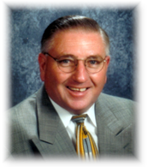

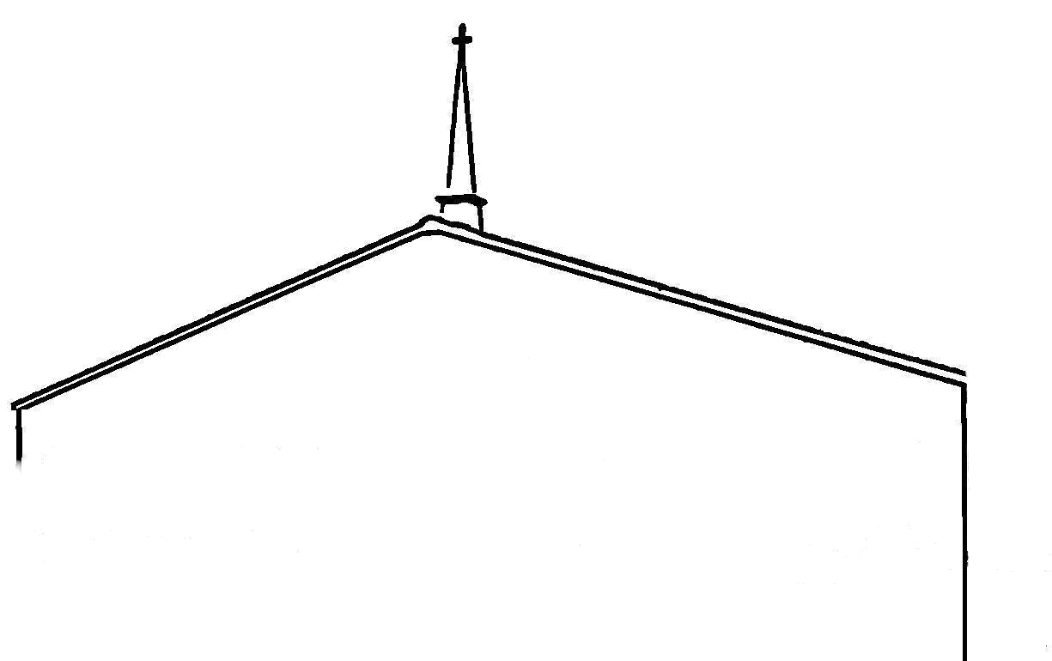
T
rinity Baptist
Church
“The fruit of the righteous is a tree of life; and he that winneth souls is wise.” Proverbs 11:30
Dr. Darrell Cox
Pastor
(336) 284 – 2404 – Office
2722 US Hwy. 601 S ♦ Mocksville, NC 27028

January 20, 2014

RE: Recommendation letter for Zachary Pope

My Dear Brother,

It is with great delight that I recommend Zach Pope, who has a burden to plant a church in the Los Angeles, California area. I have had the privilege of knowing Zach practically all of his life. I have known his dad, mom and grandparents for a long time. In fact, I used to preach for his grandfather and have preached many times for his dad, Brother Steve Pope at the Calvary Baptist Church in Union Grove, North Carolina.

I have been able to watch Zach grow up in church and serving the Lord. Zach was a student in the Christian school here at our church. He went all the way through and graduated from Trinity Baptist Academy in 2004. I don’t believe I know a finer young man any where than Brother Zach Pope.

I know that Brother Pope will be a great investment for anyone who would consider investing in him to help him get a church started in California. We are excited about supporting him here at Trinity Baptist Church. I believe we will see God do great things with him as he goes out full time to plant and then pastor a church.

I am one hundred percent for Brother Zach Pope. I recommend him to you and your church in hopes that you will consider him and his family for support as one of your missionaries. I am sure that they

would ask that you will most of all, consider taking them on for daily prayer as they go to where God has called them.

If you have any further questions, please feel free to call me at the church at 336-284-2404. Thank you for your attention to this matter.

Yours for Souls,
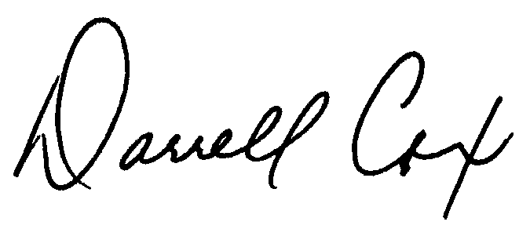
Dr. Darrell Cox, Pastor
TRINITY BAPTIST CHURCH

DRC : mb

