GROWING IN GOD’S WORD CORNERSTONE

“Stand fast therefore in the liberty wherewith BAPTIST CHURCH

Christ hath made us free, and be not entangled

again with the yoke of bondage.” 5434 7th Street

Galatians 5:1 Zephyrhills, FL 33542

813-783-2727

cornerstonebczhills.org

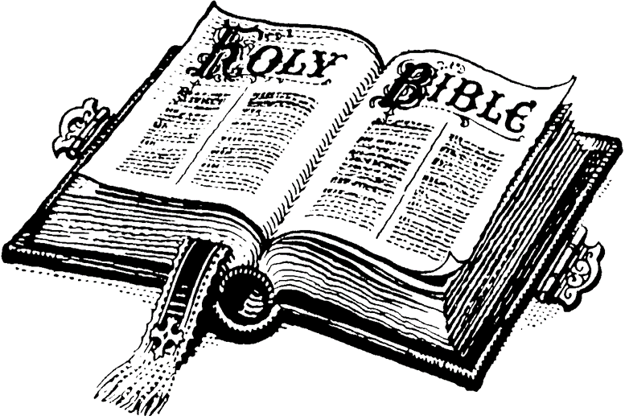

PRAY FOR AMERICA “…Jesus Christ himself being the chief corner stone…”

Ephesians 2:20

“If my people, which are called by my name,

shall humble themselves and pray, and seek

my face, and turn from their wicked ways;

then will I hear from heaven and will forgive

their sin and will heal their land.” Stephen R. Lamb, Pastor

II Chronicles 7:14 910-389-0762

July 4, 2021

The End of Your Search for an Old-Fashioned Bible Centered Church