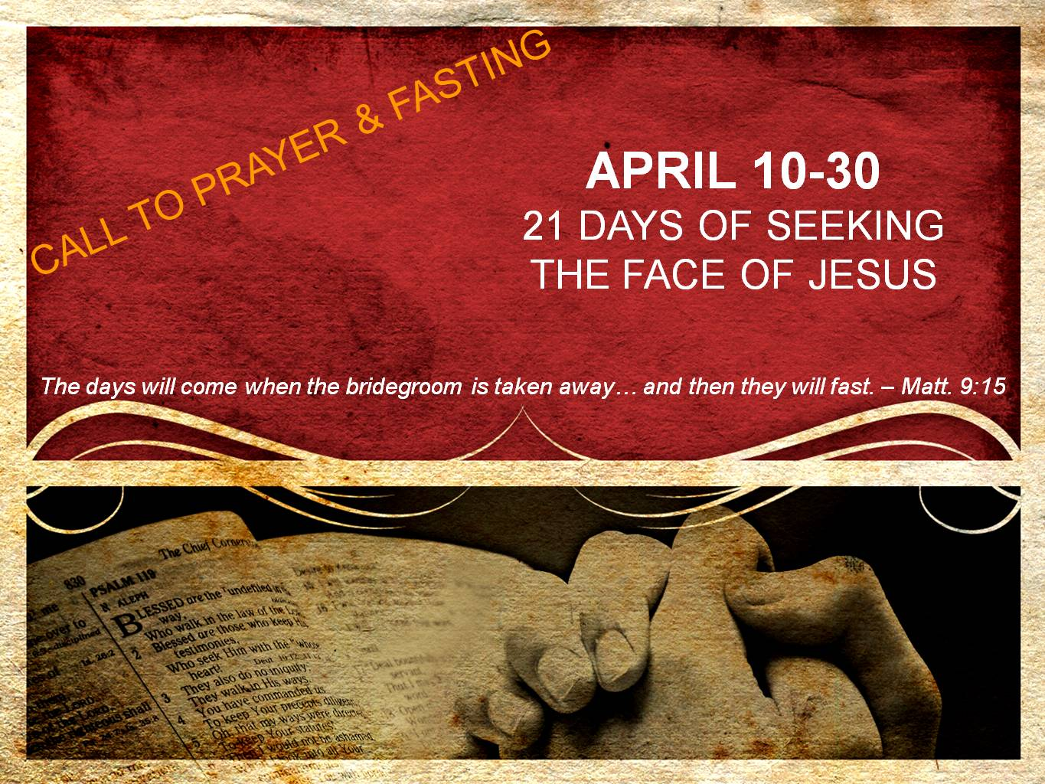  
**DAY 1**

**Longing for Jesus, our Bridegroom**

*And Jesus said to them, “The attendants of the bridegroom cannot mourn as long as the bridegroom is with them, can they? But the days will come when the bridegroom is taken away from them, and then they will fast.”* *– Matthew 9:15*

The disciples of John, who asked Jesus why his disciples did not fast, followed the tradition of the Pharisees who fasted twice a week. For them, fasting was a mark of devotion and holiness. Therefore, they were bothered that the disciples of Jesus did not seemingly take fasting more seriously – after all, they were the disciples of the Messiah!

However, Jesus states that fasting is no longer to be understood as just an outward sign of devotion, but rather as a longing for the Son of God.

During this twenty-one day fast, may our fast be from the place of longing for Jesus. For all of those who do not feel a longing, may the Spirit of God awaken a longing for the Son of God. For those who already have a longing, may the Spirit stir up an even greater longing as deep cries out to deep through denying the flesh during this fast.

**Prayer**

Jesus, my beautiful and powerful Bridegroom, awaken and stir a great hunger in my heart for You. I confess that my heart has grown hard toward you. I confess my mind wanders and sets itself on things other than You. I confess I have gone my own way and have not submitted my will to Yours. This day I repent of my wayward heart, my wayward thoughts, and my wayward will. No longer do I want to live life simply pursuing the lust of the flesh, the lust of the eyes, and the pride of life (1 Jn.2:16). I confess and repent of my sin and turn back to You, my First Love.

Jesus, soften my heart in Your presence, renew my mind in Your Word, and transform my will as I gaze upon You. I want to burn again with a holy and desperate passion for You. Set me ablaze with love for you. In great longing for You, I cry, “Jesus! Jesus! Jesus!” Amen.