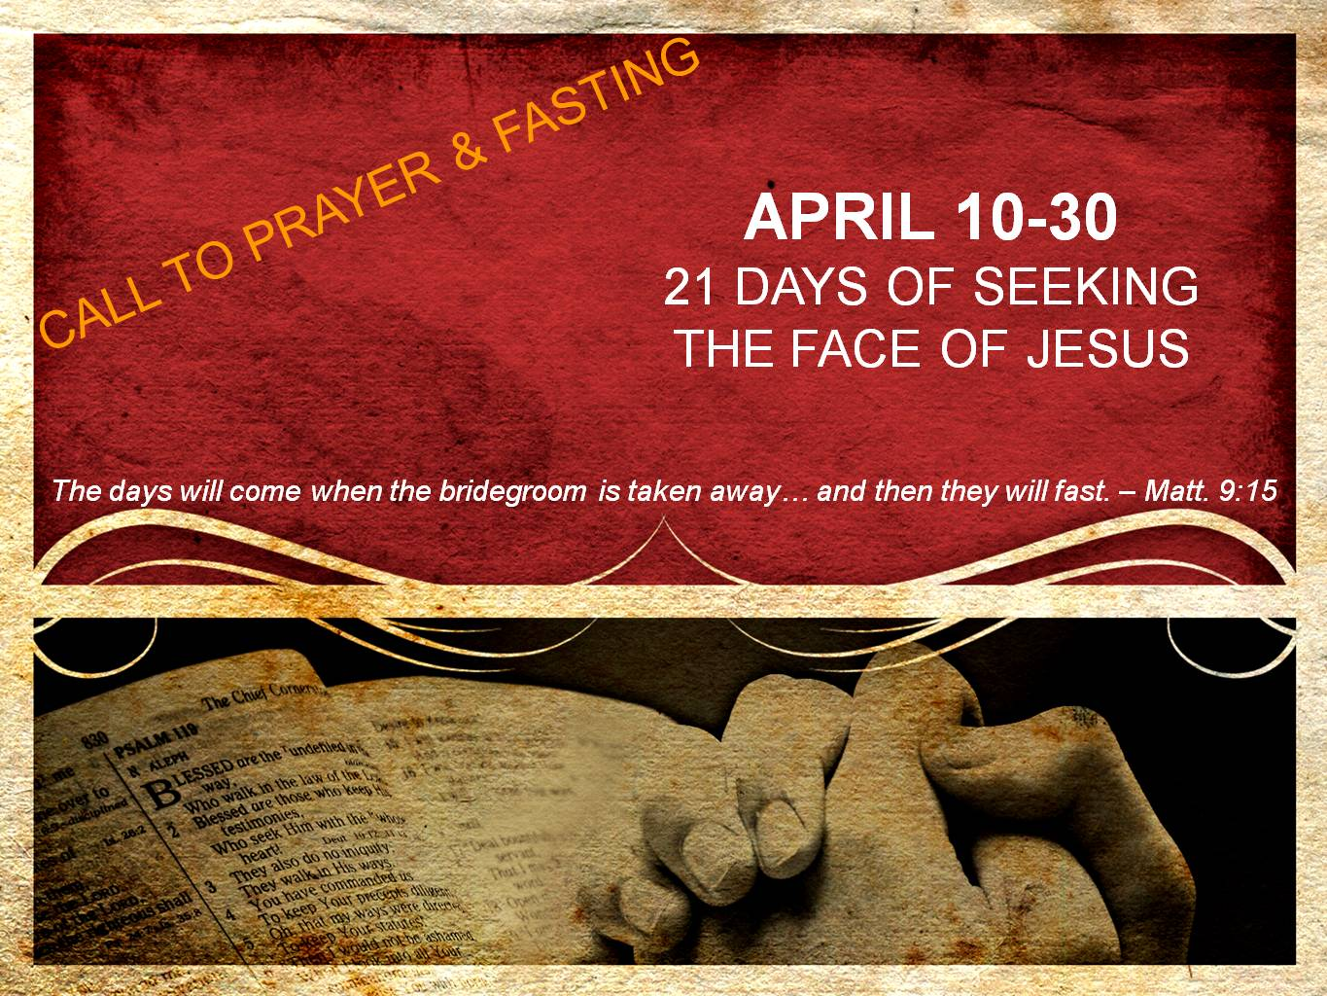  
**DAY 14**

**Renewal**

*“And the Lord will continually guide you, and satisfy your desire in scorched places, and give strength to your bones; and you will be like a watered garden, and like a spring of water whose waters do not fail. Those from among you will rebuild the ancient ruins; you will raise up the age old foundations; and you will be called the repairer of the breach, the restorer of the streets in which to dwell.’” – Isaiah 58:11-12*

True fasting carries with it the promise that the Lord will satisfy us, even in desert places. Therefore, even in seasons of being dry spiritually or being in places of hopelessness, we are assured God will satisfy us. In fact we will be “like a watered garden and a spring of waters whose waters will not fail.” Not only will we have life giving words and life giving ministry to others, but we ourselves will find that we are refreshed and renewed. What a paradox! In our fasting, in our hunger, in our abstaining from food, we will find ourselves refreshed and renewed. Only in the kingdom of God would this happen! But as we shall see, fasting is about us and His Kingdom.

In Isaiah 58:12, Isaiah is prophesying that literally there will be those who are among them in exile that will be allowed to return and rebuild the temple, the city of Jerusalem, and all the houses and buildings that were destroyed from when they were invaded and taken into exile.

Oh to God that He would see us fit to be as those who are allowed to see this nation return to its foundations. To see the church in America return to God in passion and intimacy. To see our government make decisions based on Godly and biblical principles as it once did. To see the poor helped and assisted, not used and abused for financial profit and political gain. To see our schools begin to teach the way of God again.

In other words, would God allow us to be part of a fasting community that would see a revival sweep through America that would affect every part of this nation’s fabric, and let us return to the foundations of old!

Therefore, as we fast and pray today, let us ask the Lord to begin a revival and an awakening that sweeps through our nation and returns us to the foundations of old.

**Prayer**

Father in the midst of this fast, lift my eyes up to see that fasting is impacting more than just my life – it is actually connected to larger purposes in Your Kingdom. Your heart is to see Your Bride, Your church, come alive and be ambassadors of transformation. You long for Your bride to make known Jesus, to influence our surrounding with waters that truly satisfy, and to even lead our communities back to You. Place in me today a passion for Your Kingdom to be established and expanded in my community. Give me a heart for the lost, the hurting, the needy and Your people. Today I trust You to bring a revival to Coweta Community Church and even to the church of Coweta. I love You, Jesus. Amen!