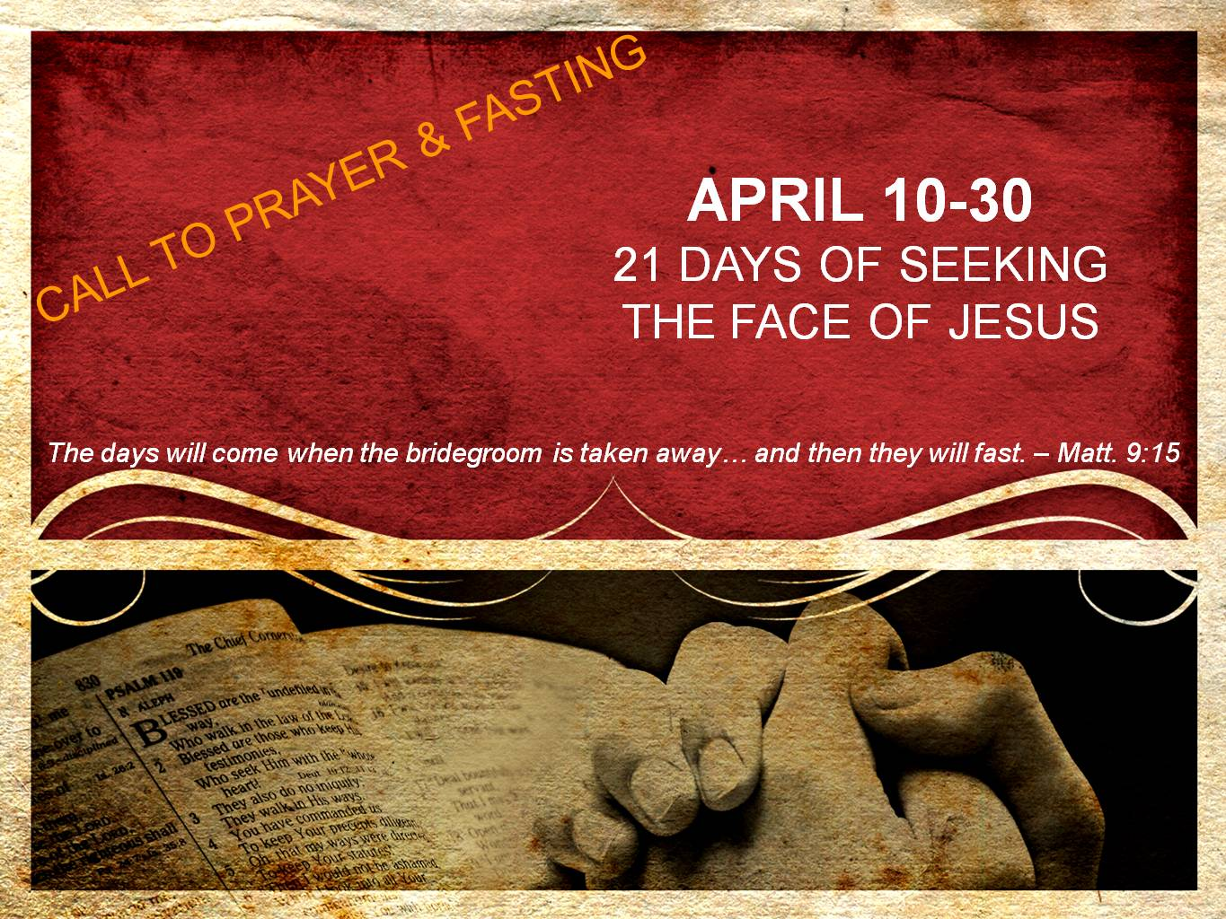  
**DAY 16**

**Fasting in the New Covenant**

*“And Jesus said to them, ‘The attendants of the bridegroom cannot mourn as long as the bridegroom is with them, can they? But the days will come when the bridegroom is taken away from them, and then they will fast. But no one puts a patch of unshrunk cloth on an old garment; for the patch pulls away from the garment, and a worse tear results. Nor do people put new wine into old wineskins; otherwise the wineskins burst, and the wine pours out and the wineskins are ruined; but they put new wine into fresh wineskins, and both are preserved.’” – Matthew 9:15-17*

Just as one does not sow a new patch on an old garment or pour new wine into an old wineskin, nor can the realities of the new covenant fit into the customs of old. The Law is holy and good (Romans 7:12-13), however the Law could never save, never justify, and never make us righteous (see Galatians 3). Rather, the Law was put into place because of sin to direct us to Christ (Gal. 3:19, 24). When Christ came, the Old Covenant, and the law which undergirded it, gave way to a New Covenant.

This New Covenant introduced salvation by grace through faith. No longer would salvation be earned through works or the keeping of the Law. Rather, because of the substitutionary death of Jesus on the cross which conquered sin & His resurrection which conquered death, all who repent and believe in Him are transferred from the kingdom of darkness into the Kingdom of God and will spend eternity with Him.

The New Covenant also would forever change the motives for fasting. One might still fast when asking the Lord to give them wisdom in making a decision or fast to gain victory over an area of sin. However, we view this through the New Covenant lens of not earning something from God by our works, but rather seeking Jesus and understanding that He is a rewarder of those who seek Him (Heb. 11:6). Thus, even in these types of fasts we understand that New Covenant fasting is truly about one thing: a longing for the Son of God!

Let this be a day where we rejoice living in the New Covenant and rejoice in our time of fasting as we draw ever closer to the Bridegroom who delivered us and reconciled us to Himself.

**Prayer**

Jesus, fill my heart with gratefulness as I meditate once again on the realities of living in the glorious New Covenant. I thank You that You would love me so much, that You would take my place on the cross, You would shed Your blood for me, and that You would rise from the grave that I might have life everlasting. I thank You that Your blood has made a new and living way for me. I thank You that I live under grace and not under Law. I thank You that I do not have to try and earn Your love. Rather, Your love has been freely given to me and You say You are pleased in me, not because of my works, but because of faith. Thank You that this fast is not about trying to earn something from You. Rather, I fast because I have a great longing for You and I want to know You in greater and deeper ways. Jesus, I want to know Your heart, I want to see Your face, and I want to hear Your voice. Draw me ever closer to You. I love You, Jesus. Amen.