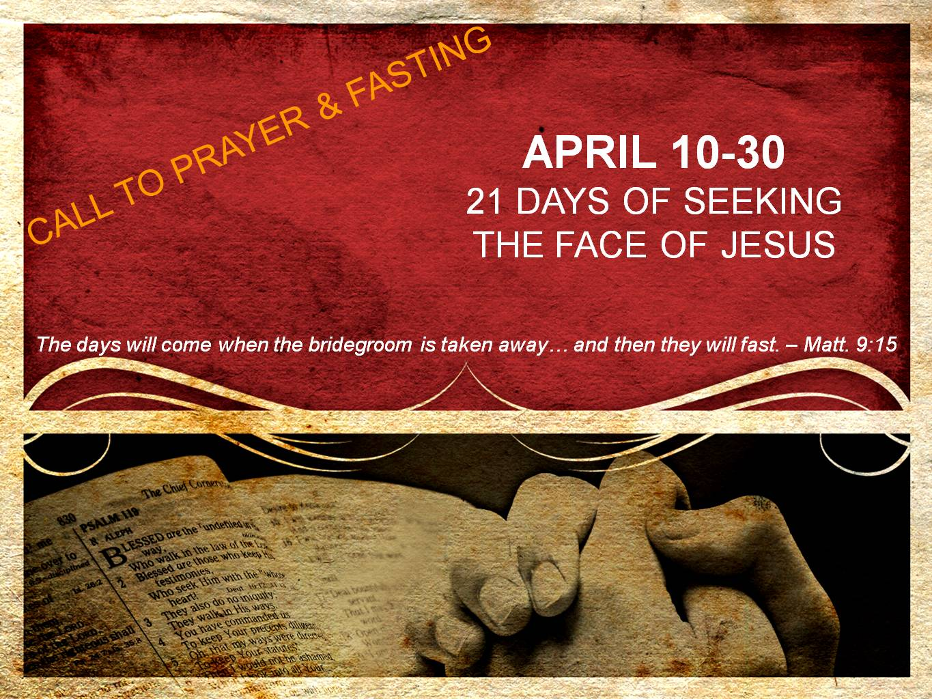  
**DAY 2**

**Revelation of Jesus as our Bridegroom**

*And Jesus said to them, “The attendants of the bridegroom cannot mourn as long as the bridegroom is with them, can they? But the days will come when the bridegroom is taken away from them, and then they will fast.”* *– Matthew 9:15*

There are many of us who do not relate to Jesus as a Bridegroom – at least not very well. As a male it may just seem weird to relate to Jesus as a Bridegroom. As a female who has never been married, you may not have a context of what a bridegroom is. Or it could be that you are a female who has been married and has been hurt by a bridegroom. Others of us simply have never considered it, or at least never considered it seriously. However, since Jesus states that one of the ways in which He chose to reveal His relationship with His church is through the picture of a bridegroom & bride (Eph. 5:22-32), let us pause and ask Jesus for a spirit of revelation in the knowledge of Him as our Bridegroom. Keeping in mind that He is not the reflection of an earthly bridegroom, but rather the perfection of an earthly bridegroom – He is the perfect bridegroom.

Let us slowly meditate on these truths of Jesus, as our Bridegroom. He is the Bridegroom who will protect us & deliver us with His might, while singing over us with gladness (Zeph. 3:17). He is the One who will rejoice over us (Is. 62:5), whose desire is toward us (Song of Sol 7:10 – yes, He really likes you!), who is overcome as we simply look at Him (Song of Sol 4:9 – this is the great power of His blood!), and calls our love toward Him beautiful, even when that love is weak at times (Song of Sol 4:10). He is the Bridegroom who will cherish us in love and will provide for us in everything we need (Eph 5:29), promising to present us as holy and blameless (Eph 5:27). He is the Bridegroom who is always enjoyable to be around as He gives us fullness of joy as we hear His voice & are found in His presence (Jn. 3:29). He is the One who knows us intimately and desires for us to know Him intimately (Hosea 2:20).

**Prayer**

Jesus, in my great longing for You, I ask for You to reveal Yourself to me as the Bridegroom who is my Protector, my Deliverer, the great Lover of my soul, and my Provider. You have set me apart for You and You alone. Forgive me when I have not trusted You as my Bridegroom. I repent and trust my spirit, soul & body to You. Therefore, I cast down all other lovers who fight for my affection and devotion, and I set my gaze on You alone. For You alone are my Bridegroom, and as Your bride I belong to only You.

Grant me to know Your affections and thoughts toward me which are pleasurable and more numerous than the grains of sand on this earth. That I might rejoice and have a peace in You which passes all understanding as I come to know You as the beautiful & powerful Bridegroom who knows me intimately, and who has invited me to know You intimately. I love You, Jesus. My soul even longs for You. Amen.