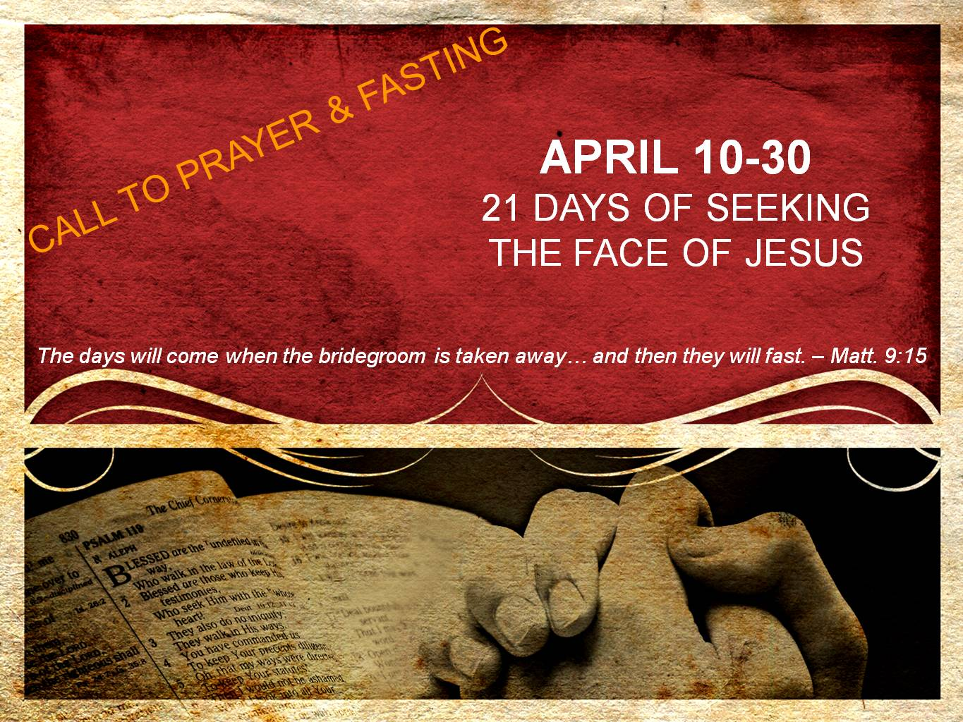  
**DAY 3**

**Friend of the Bridegroom**

*“He who has the bride is the bridegroom; but the friend of the bridegroom, who stands and hears him, rejoices greatly because of the bridegroom’s voice. So this joy of mine has been made full.” – John 3:29*

Friend. This powerful word has lost so much meaning in our day and time. Yet, Jesus calls us His friends.

Jesus states, “Greater love has no one than this, that one lay down his life for his friends. You are My friends” (Jn. 15:13-14a). Friends? Really? How can Jesus call us friends? If He was simply speaking about the twelve this would be scandalous enough. For Peter denied, Judas betrayed, and all except John ran away. Yet, He was not speaking of just the twelve, but rather all who would follow Him. And I don’t see Him dying for friends – I see Him dying for His enemies.

We were dead in our sin, far away from Him, at enmity with Him, not for Him but against Him. We were children of wrath living according to Satan & this world. There was nothing good found in us – there were none righteous, no not even one.

I consider where I was before I knew the Lord, and I shudder. I shudder to think where I would be without Him, and I shudder as I consider who I was to Him before salvation.

Yet for me, for you, He looked at us even while dying on the cross, and I hear Him say, “Greater love has no one than this, that I lay down My life for you – My friend.”

Jesus is our Bridegroom, and we are His bride. We are also His friend. We are the ones He died for, the ones He rose for, the ones He ascended for, and the ones He is returning for.

He calls us friend. Will we call Him friend in return? Will we lay our lives down for Him? Will we stand near to Him when it is difficult, uncomfortable, unpopular, & countercultural? How can we not, when He was willing to endure the difficult, uncomfortable, unpopular, & countercultural cross for us, His friends?

**Prayer**

Jesus, I confess I have not always been a faithful friend to You. Forgive me as I repent for when I have found myself too ashamed and too embarrassed to always stand near You and call You friend. I also repent for when I have been too distracted or too inconvenienced to spend time with you as a friend should.

I realize anew today that when I did not deserve it, You died in my place. When I did not deserve it, you extended mercy and grace. All so that You could call me friend.

Help me to never take this for granted again. And may I live my life denying myself, taking up my cross, and following You, Jesus, as a friend of the Bridegroom. I love You, Jesus. Amen.