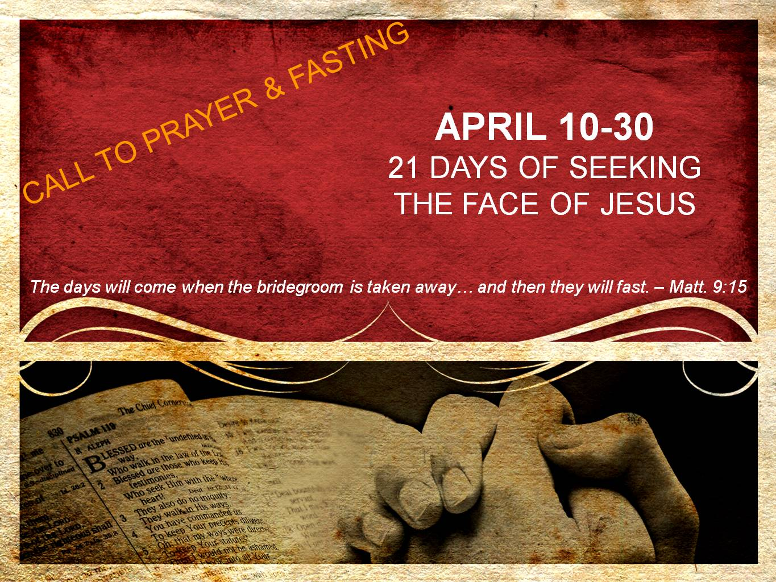  
**DAY 4**

**Standing with the Bridegroom**

*“He who has the bride is the bridegroom; but the friend of the bridegroom, who stands and hears him, rejoices greatly because of the bridegroom’s voice. So this joy of mine has been made full.” – John 3:29*

John the Baptist had a thriving ministry preaching repentance and leading more people into a baptism of repentance than he could count. He even had his own group of disciples. When Jesus began His public ministry, John continued baptizing people and his disciples continued to follow him. Yet, this man whom Jesus would call the greatest man born of a woman (Matt. 11:11), realized that he was simply created to point to the One who was the Messiah. John knew he was not the Bridegroom – he was the friend of the Bridegroom. And as a friend of the Bridegroom, John’s first responsibility was to stand with Jesus.

To stand with Jesus is to assume a radical posture. It is a posture in which one defers to Jesus in all situations at all times. This is a bowing of one’s will to always be found with Jesus.

I want to be found standing as one accounted for – standing at attention at all times ready to say, “Yes” to the will of my Bridegroom. Regardless of what this means for my reputation, my ministry (which is really His anyways) and my sense of comfort, I want to stand with the One whom I was created to glorify, stand with, and point to – Jesus, my Bridegroom.

**Prayer**

Jesus, because You are my Bridegroom, I know you are fully trustworthy. You promise to protect, love and provide for me. Therefore, standing next to you is the safest place I can be. Lord, when standing next to you is not comfortable, when it means I have to deny myself, take up my cross and follow you, let me be found faithful in my standing. And may all my life point to the One whom I am standing with, Jesus, my Bridegroom. Again I say, I love You, Jesus. Amen.