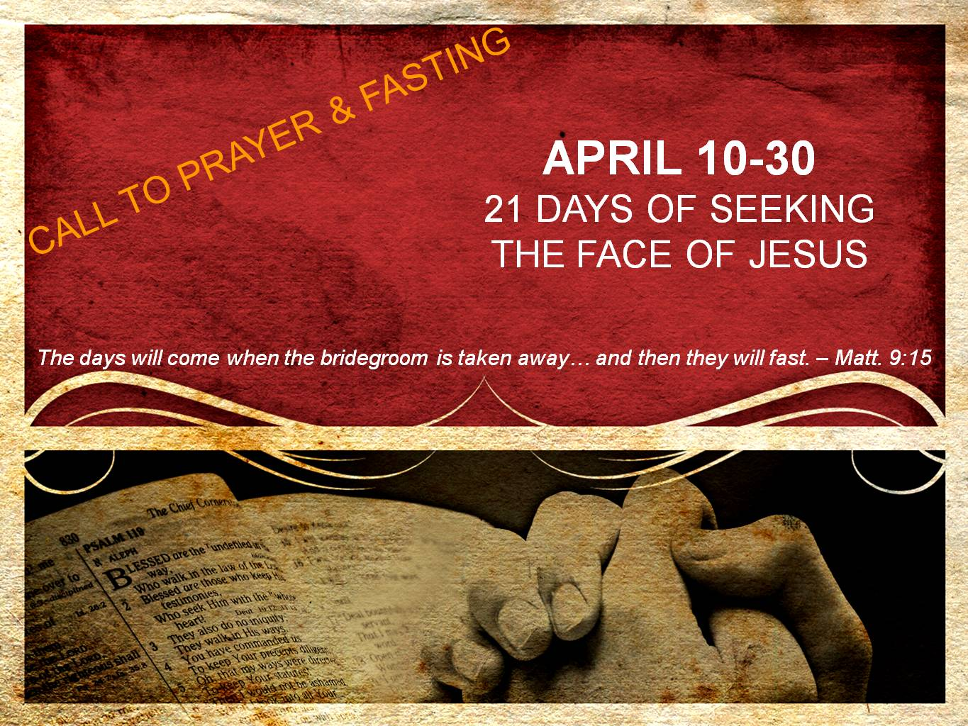  
**DAY 6**

**Hearing the voice of the Bridegroom**

*“He who has the bride is the bridegroom; but the friend of the bridegroom, who stands and hears him, rejoices greatly because of the bridegroom’s voice. So this joy of mine has been made full.” – John 3:29*

In our hectic, fast-paced world, our minds are constantly bombarded with noise. Some of this “noise” is actually encouraging, such as the voices of preachers, worship leaders, family and friends. Other voices, like music & talk-radio, are simply distracting. While still others (think 11:00 news), can be downright depressing.

Our challenge, in this day and time where we are inundated with the noise of social-media, YouTube, TV, radio, along with the conversations we have with our family, friends, neighbors, and co-workers, is to pause and be silent to hear from our Bridegroom.

Jesus is always thinking about us, He sings over us, and He speaks to us. The only question is if we are listening.

As we fast this week, let us be intentional to hear from Jesus. Whether it is during the time you would normally eat a meal or watch the TV, take time to be silent and hear what your Bridegroom is longing to say.

Hearing one word from Jesus can change our lives – for only He has the words of eternal life.

**Prayer**

Jesus, forgive me for not listening to Your voice. Forgive me for being so distracted with all the other voices and noise in this world that I have stopped listening to the only One whose words are eternal life. Grant me a grace to intentionally set apart time to listen to You – not just listen to another sermon or latest worship song – but listen to You. And as I set apart this time, may I become so familiar with Your voice that I hear You speak to me all throughout the day, regardless of what I am doing. I love you, Jesus. Amen.