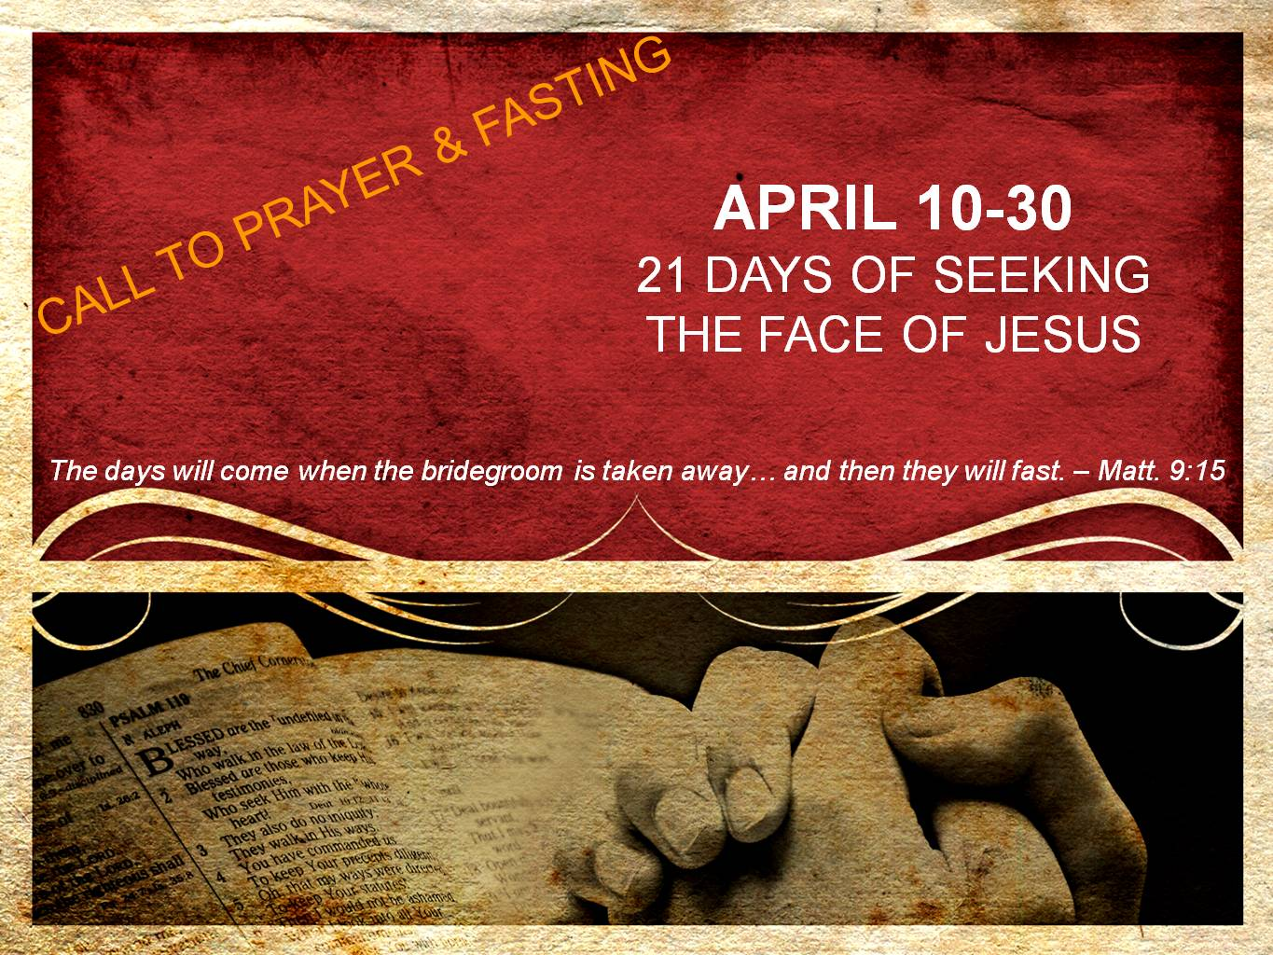  
**DAY 7**

**Fullness of Joy in the Bridegroom**

*“He who has the bride is the bridegroom; but the friend of the bridegroom, who stands and hears him, rejoices greatly because of the bridegroom’s voice. So this joy of mine has been made full.” – John 3:29*

When Jesus speaks our hearts should be overwhelmed that the King of the universe, the One who is in all and through all and who is holy & majestic with none like Him, has spoken to us. For who are we that God should speak to us? Were we not the ones who were far from Him while dead in our sin?

Yes, this *was* our former manner of life. Yet, the gospel declares that the great Creator God extended grace to us when we were still in our sin and the blood of Jesus has made a new and living way for us to once again be brought near to Him and stand with the Bridegroom.

Therefore, as we stand with the Bridegroom and hear His voice, let joy overcome our hearts in the revelation that we - yes those once far away - not only are saved, but have been brought into an intimate relationship with our friend and our Bridegroom.

The Bridegroom is speaking! Do His words not cause our hearts to burn like the hearts of the two men on the road to Emmaus? Oh that we would hear His voice and have our hearts made full with joy, unspeakable joy!

**Prayer**

Jesus, I confess that at times I have taken hearing Your voice for granted. Forgive me, and remind me what a great honor it is to stand with You and hear Your voice. Today I ask for you to cause the revelation of Your great mercy toward me to pierce my heart. Would this revelation in connection with Your voice cause my joy to be made full. Whether I am found in the darkest, lowest valley or the brightest, highest of heights, may joy be made full in hearing Your voice. I ask today for joy, unspeakable joy to flood my being! I want to be overwhelmed with Your presence, Your love and Your joy. I want to truly enjoy the purity of being in Your presence and hearing Your voice. There is nowhere else I would rather be than in Your presence as You sing over me. I love You, Jesus! Amen.