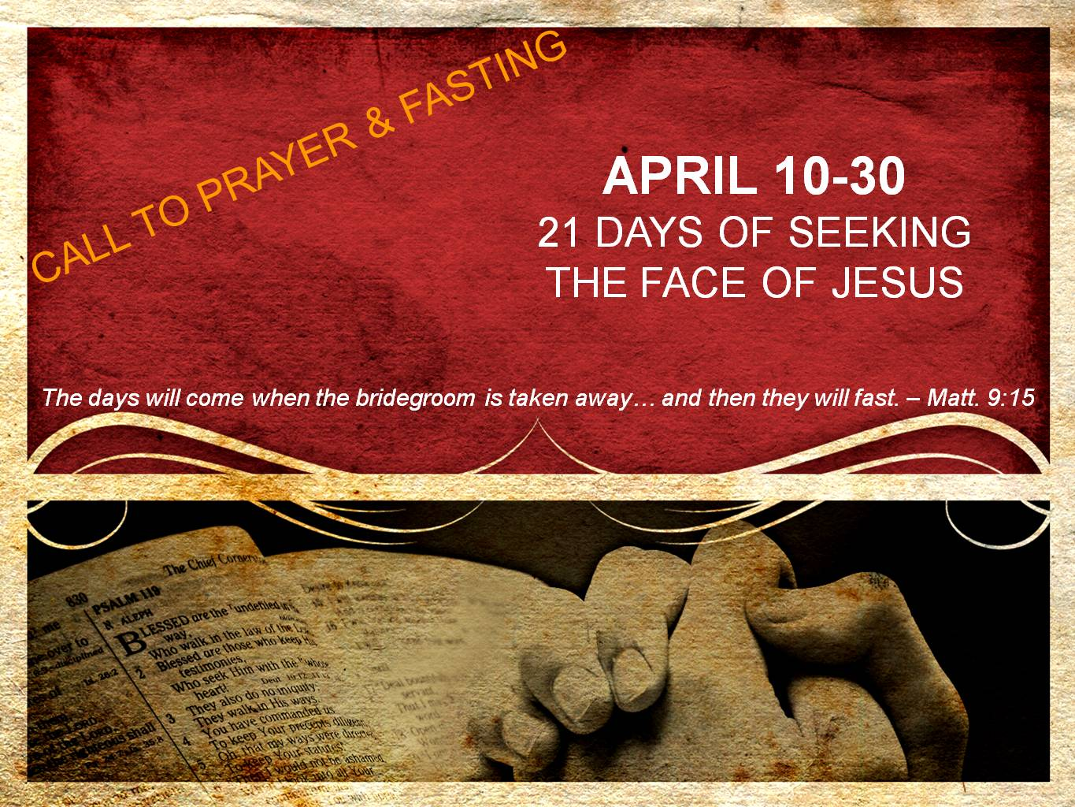  
**DAYS 10 & 11**

**Mercy**

*“Is it not to divide your bread with the hungry and bring the homeless poor into the house; when you see the naked, to cover him; and not to hide yourself from your own flesh…And if you give yourself to the hungry and satisfy the desire of the afflicted, then your light will rise in darkness and your gloom will become like midday.” – Isaiah 58:7,10*

Fasting is not easy – especially when fasting for an extended time like 21 days. We become hungry, tired, and we just wish we could eat something that would really satisfy us. Welcome to the feeling that hundreds of millions of men, women and children feel everyday. However, unlike us, their hunger will remain.

Fasting because of a longing for Jesus should align us with not only His affections toward us, but also His affections to the “least of these.” For you see, serving the least of these, Jesus says, is the same as serving Him (Matthew 25:40).

In this season of fasting, as we ask the Lord for a more tender heart toward Him, let us not be surprised when He awakens a more tender heart for the hungry, the homeless, the poor & the afflicted. We might consider serving at a local soup kitchen or homeless shelter. Compassion International and OM India also have wonderful opportunities for us to contribute one time gifts toward caring for children in third-world countries, or even making a commitment to sponsor a child. You can also partner with the END IT NOW MOVEMENT to help end the sex-slave industry.

The promise of having our light rise and our gloom fade away as we give ourselves to those in need is hinged upon these three factors: we are being obedient to the Lord to care for the least of these, we are ministering to Jesus as we minister to those in need, and third we realize our circumstances and situations pale in comparison to the plight of so many in this world.

Give yourself to the least of these and watch in amazement as God stirs your heart in ways you have never experienced before.

**Prayer**

Father, forgive me as I have turned a blind-eye and an indifferent heart toward those who are most in need in our world. Forgive me for thinking I could faithfully love You without faithfully loving the least of these. During the remainder of this fast, I commit to reaching out in a tangible way to the hungry, homeless, poor, and afflicted. Direct my steps to those you would have me serve, and give me a compassion for all of those in need. Thank You for the mercy You have extended to me, one who did not deserve Your mercy. Give me a grace to extend mercyan K`hank You in the same way to all of those whom I come in contact with. I am humbled by Your love and mercy. I love You, Jesus. Amen.