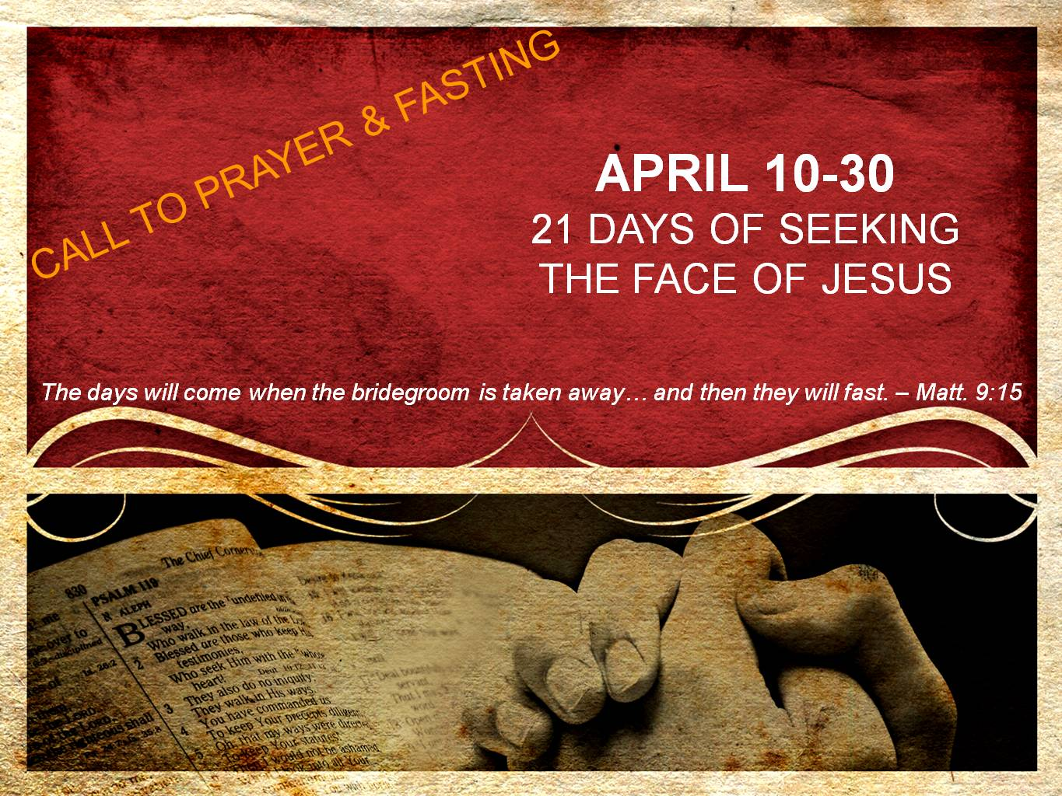  
**DAYS 12 & 13**

**Glory**

*“Then your light will break out like the dawn, and your recovery will speedily spring forth; and your righteousness will go before you; the glory of the Lord will be your rear guard. Then you will call, and the Lord will answer; you will cry, and He will say, ‘Here I am.’” – Isaiah 58:8-9a*

Light breaking out; healing springing forth; righteousness before you; glory guarding you; answered prayer; in the presence of the Lord – sign me up!

These are the promises if we fast while abiding in Jesus and caring for those in need. With these types of promises, why would we not fast more often? The answer is simple: denying the flesh is difficult.

We long for more of the Lord, yet our flesh is at war with the Spirit within us. Fasting is one of the ways in which we sow into the Spirit, deny our flesh, and position ourselves to encounter the glory of God in greater ways. Therefore, do not grow weary in fasting, nor become discouraged that you are not seeing a manifestation of God while fasting. The promise is *if* we fast, *then* we will reap these promises of fasting. The *then* is coming!

Remain faithful in the fast, and watch as God causes His light to radiate through you, His healing to come upon you, His righteousness to break strongholds of sin, His glory to guard you, His ear to be turned toward you, and His presence to surround you. Hallelujah!

**Prayer**

Father, I confess that the spirit is willing and the flesh is weak. Therefore, I throw myself upon Your mercy again today. I confess that I need Your grace to continue denying my flesh through this fast. I do not want to stop now. I want to press on, believing that You have greater promises for me than the satisfaction of temporal things. Thank You for Your grace, and I believe that Your light is breaking out, Your healing is springing forth, and Your righteousness is in me & going before me to make a way where there was no way. I believe Your glory is my guard, Your ear is turned toward my cry, and Your presence is coming upon me in ways I have never known. I do believe in faith that today is a new day and Your kingdom is advancing in my life. I love You, Jesus. Amen.