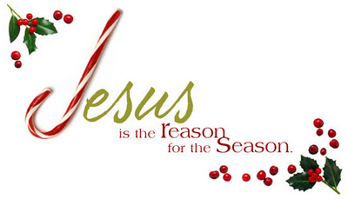
This is a prophetic Christmas Party. Please read the following information carefully. It is a guide to help you.
- Please pray about the gift you will be purchasing and buy what the Lord directs you to buy. Then write on a card what the Lord is saying about the person that will receive the gift. (You won’t know who that will be. God alone knows.) This will make the gift prophetic and what you are saying to that person will be from the Lord also. Each gift will be numbered. Then each person will draw a number, open the gift with that particular number and the person that purchased the gift will read what she’s written on the card as she presents the gift to the recipient. (If you draw your own number, you will draw again.) Please do your best to keep your speaking to about two minutes or less. Keep in mind that 65 people times two minutes is over two hours.
- You will be so blessed to see and hear how the Lord uses you! You may be asking, “What if I’m unsure about this?” We are here as a family to learn and to exercise our prophetic muscles. When the evening is over, each of us will be pleasantly surprised how God used every one of us to bless another person. In the past, we have kept the spending to $10.00. Use your own judgment as the Lord leads. (See the important prophetic word below!)
- If you get stuck and feel that this is too hard for you, talk with any of the committee members or folks that have attended in past years. We had one lady that had decided not to come one year and then it was mentioned to her how prophetic she is with poetry and she wrote a poem. Later she said, “This is really easy.” Let’s not make it harder than it is. God is able! Just ask anyone that attended in the past.
- That evening, please plan to bring your prophetic gift and arrive by 4:30 p.m. Remember, this is an RSVP event with many details involved; therefore, we must insist upon people purchasing tickets. Thanks so much!

The Lord spoke to me (Sharon) about this year’s party already. One day I was cleaning out my closet and I found a brand new very nice item that could be an extremely nice gift. To my surprise, the Lord said, “That’s your gift for the Christmas party.” Then, he proceeded to give me the word for the person. He then said tell the ladies, “These are tight times; look in your closets and drawers.

God is amazing! He never skips a beat! Get ready to have Jesus rock your world! This is no exaggeration! Ask others that have attended in the past! ☺

