Resurrection Sunday
Here is a picture of our congregation from Resurrection Sunday. More pictures are available on our website at www.EastGateMBC.com in the “Picture Gallery”. April was a very good month. We had some visitors from Texas that came out to see their new grandson; Raymond Christopher Lilley was born this month to the Lilley family. All are doing well. We are thankful for the Lord’s blessings on us. Please keep us in your prayers.

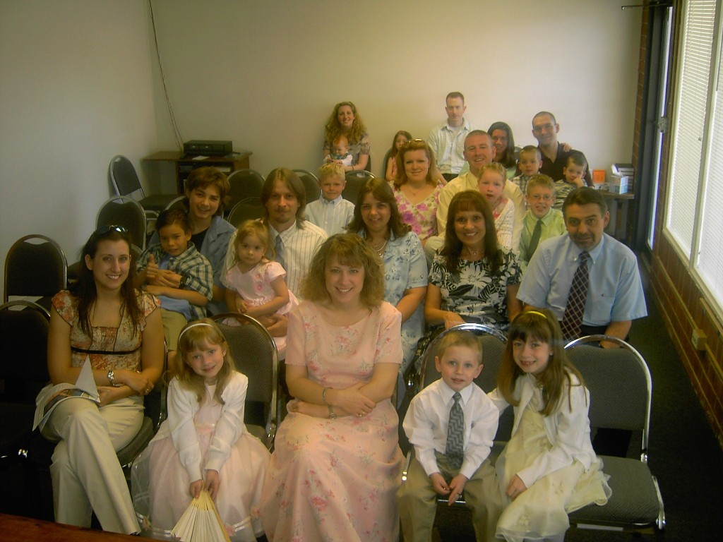

Building update and Special Request
We are still actively searching for a new building and trust the Lord will provide what we need. Thankfully, we were able to determine the issues with the other building before we purchased it. I would like to request that any churches who might want to help with this to please consider a one-time offering to help with the purchase of property and building. Also, if we are not able to purchase a suitable building by August, we will at least need to lease a larger space and also request consideration for monthly support for this area. Any designated offerings for either of these purposes can be noted with the offering when sent to Cross Road MBC, address below.

New Support received
Promise Land MBC of Hamburg, Arkansas sent us an offering of $500 this month. We are very appreciative of this church and her support for us. Thank you so much Brother Reese and Promise Land MBC! I would like to also thank the Bartholomew Association for sending us the offering for their Mission Rally.

Support
Financial support can be sent to this address:
Cross Road MBC
c/o John Nowlin
111 Ashley 391
Crossett, AR 71635
Please see the financial report for a full list of those who sent financial support to us this month. We are truly blessed to have faithful friends and sister churches that are willing to support the work here in Colorado Springs. I don’t always mention them but they all have a special place in my heart and in my prayers. Thank you all.

In the grace of our Lord and Savior, Jesus Christ,

Paul Breshears – Missionary Pastor of East Gate MBC
Our Website: www.eastgatembc.com
Sponsored by Cross Road MBC – Crossett, AR

Beginning Balance |  |  |  | $4,028.97
Contributions
Pleasant Ridge MBC - Rison, AR (2 months) |  | $250.00
Egypt MBC – Hamburg, AR |  | $500.00
Egypt MBC Ladies - Hamburg, AR |  | $25.00
Bartholomew Association Mission Fund |  | $250.00
Bartholomew Association Mission Rally |  | $385.00
New Hope MBC - Rison, AR |  | $100.00
Antioch MBC - Van Buren, AR |  | $100.00
Promise Land MBC - Hamburg, AR |  | $500.00
Cross Road MBC - Crossett, AR |  | $781.52
East Gate Tithes and Offerings |  | $1,750.62
Total Contributions |  |  | $4,642.14
Expenses
Lease payment - April |  | $1,050.00
Crown Publications - website |  | $29.95
CS Utilities |  | $86.61
Qwest Phone |  | $47.42
Missions (2 months) |  | $200.00
Laptop coverage - Circuit City (second payment) |  | $65.33
ABA Bookstore - Ladies Meeting Study Books (10) |  | $80.93
Nursery supplies - changing table pad, etc |  | $38.63
Home Depot - supplies and lightbulbs |  | $68.50
Cleaning supplies |  | $41.96
Transfer to Bldg fund (10% of East Gate MBC Offerings) |  | $174.36
Pastor salary |  | $1,784.31
Total Expenses |  |  | ($3,668.00)
Increase/Decrease for month |  |  |  | $974.14
Balance as of April 30 |  |  |  | $5,003.11
Building Fund
Beginning balance |  |  |  | $707.70
Earnest money return |  |  | $5,000.00
Cross Road MBC - Crossett, AR |  |  | $310.00
Sublet Road MBC - Arlington, TX |  |  | $50.00
10% of East Gate MBC offerings |  |  | $174.36
Spare Change Collection - East Gate MBC |  |  | $8.24
Interest for April |  |  | $0.10
Ending balance |  |  |  | $6,250.40
Attendance Avg | Service
18 | SS
23 | SM
21 | SE
17 | MW

