New Location
We were so thankful to finally get to start the remodel work on our new location. We signed a contract to have the work done in a month and we held our first service there September 9th. We are very thankful to all of those who have helped us in various ways to get to this point, and request that you continue to lift us up in your prayers.
Our new meeting address is 1875 N. Academy Blvd Suite #100, Colorado Springs, CO 80909. Our mailing address remains 12278 Isle Royale Dr., Peyton, CO 80831. I will be posting more pictures on our website as well as a map to our location soon. Here are a few pictures of our first services in the new location. I hope they turn out ok.

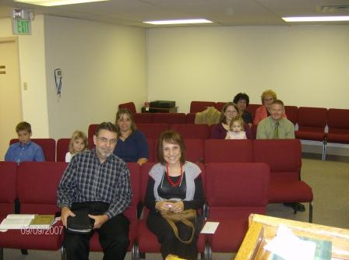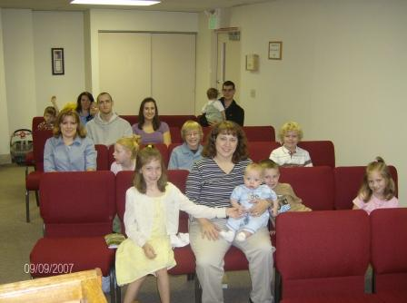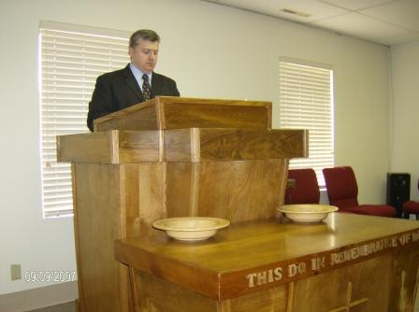

New Visitor
We were blessed to welcome a new visitor in August. Joe Huckabee recently moved to Colorado Springs and is a member of Lone Mountain MBC of Las Vegas, NV. Please pray for Joe as he gets settled in here in Colorado Springs and that he would know the Lord’s will for his life and follow it. We have another young man that has been visiting with us for a while and I would ask that you would pray for him to follow the Lord in scriptural baptism and membership here at East Gate.

Friends of East Gate
There are many individuals and families that have given directly to support the work here in Colorado Springs. I would like to mention them this month and say a special thank you to each one, but I am afraid I would forget someone. Please know that you all have had a special part in what the Lord has done here in Colorado Springs through East Gate and I know the Lord has blessed you and pray that He will continue to bless you for your benevolence towards His churches. Please know that you have all been a blessing to me personally and to the church here. Thank you for everything.

Address
Financial support can be sent to this address:
Cross Road MBC
c/o John Nowlin
111 Ashley 391
Crossett, AR 71635

In the grace of our Lord and Savior, Jesus Christ,

Paul Breshears – Missionary Pastor of East Gate MBC
Our Website: www.eastgatembc.com

Beginning Balance |  |  |  | $20,680.94
Contributions
Wagonwheel MBC - Henderson, NV |  | $100.00
Antioch MBC - Alma, Ar |  | $170.09
Egypt MBC - Hamburg, AR |  | $500.00
Calvary MBC - Aurora, Co |  | $221.88
Bartholomew Association Mission Fund |  | $250.00
South Crossett MBC - Crossett, AR |  | $50.00
New Hope MBC - Rison, AR |  | $236.00
Cross Road MBC - Crossett, AR |  | $678.82
Jason & Sara Cater |  | $1,500.00
Mr. & Mrs. Ides Evans |  | $20.00
West Crossett MBC - Crossett, AR (Pastor Salary) |  | $328.07
East Gate Tithes and Offerings |  | $3,290.96
Total Contributions |  |  | $7,345.82
Expenses
Lease payment |  | $1,050.00
Global Construction |  | $1,000.00
Quality Construction |  | $4,430.82
Budget Chairs |  | $4,099.00
Travel expenses to ABA Meeting |  | $60.00
ABA Meeting |  | $50.00
Baptist Bookstore |  | $136.21
Crown Publications - website |  | $29.95
CS Utilities |  | $86.02
Qwest Phone |  | $47.41
Missions |  | $100.00
King Soopers |  | $26.40
Transfer to Bldg fund (10% of East Gate MBC Offerings) |  | $329.09
Pastor salary |  | $3,003.53
Total Expenses |  |  | ($14,448.43)
Increase/Decrease for month |  |  |  | ($7,102.61)
Ending Balance |  |  |  | $13,578.33
Building Fund
Beginning balance |  |  |  | $30,142.26
Cross Road MBC - Crossett, AR |  |  | $150.00
Landmark MBC - Delta, CO |  |  | $156.37
Bartholomew Association Mission Fund |  |  | $250.00
Quality Construction, LLC |  |  | ($25,569.18)
Loan Payment - First State Bank Crossett, AR |  |  | ($422.43)
CSU deposit refund |  |  | $280.07
10% of East Gate MBC offerings |  |  | $329.09
Spare Change Collection - East Gate MBC |  |  | $25.41
Interest |  |  | $0.13
Ending balance |  |  |  | $5,341.72
Youth Fund
Beginning balance |  |  |  | $300.00
Ending balance |  |  |  | $300.00

Attendance: SS – 17, SM – 19, SE – 17, WE – 18

