December Blessings
As we come to the end of the year 2005, many take this time to reflect on the blessings we have received from the Lord. Most importantly, though, I think we need to remember that the blessings come from Him and are undeserved on our part. His grace is beyond my ability to communicate. I think only the ones who have seen first hand the blessings can truly appreciate them. I would like to thank each and every person and church that has been a part of the support for this work. Only the Lord truly knows what all has been done and I trust that He will bless each and every one of you in accordance with His will.

Here are a couple of photos from Christmas day; I hope they come out ok.
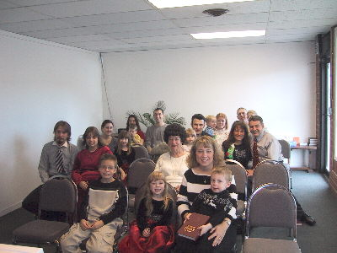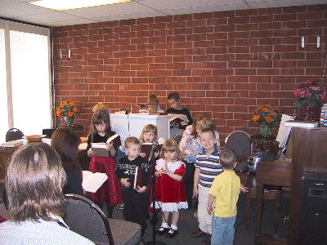

Building update
I had the opportunity to speak with the man who helped us to get the lease on the place we are currently meeting and along with sharing with him information about the good news of Jesus Christ; he gave me some ideas on what he might be able to do to help us get a permanent meeting place. This was truly a blessing, and he seemed open to the scriptures and very interested. I will be meeting with him again after the first of the year. Please pray for him, his name is Steve Leigh.

Support
In December, we learned that New Hope Missionary Baptist Church of Rison, AR has chosen to begin supporting the work here at East Gate MBC. Thank you for this support. You are in our prayers that the Lord would bless you greatly.
I would like to encourage anyone that is looking for a mission work to support to please consider our work here in Colorado Springs.
Financial support can be sent to this address:
Cross Road MBC
111 Ashley 391
Crossett, AR 71635
Please see the financial report for a full list of those who sent financial support to us this month. Due to the Christmas season some of our support for the month didn’t make it to our sponsoring church in time for this month’s report.

In the grace of our Lord and Savior, Jesus Christ,

Paul Breshears – Missionary Pastor of East Gate MBC
Our Website: www.eastgatembc.com

Beginning Balance |  |  |  | $3,195.84
Special Love offerings
East Gate MBC for Coleman family |  | $63.00
Coleman family gift card purchase - Babies 'R US |  | ($63.00)
Contributions
Support
Bartholomew Assoc Mission Fund Monthly |  | $250.00
Antioch MBC - Van Buren, AR (2 months) |  | $200.00
Pleasant Ridge MBC - Rison, AR |  | $125.00
Egypt MBC - Hamburg, AR (2 months) |  | $1,000.00
Cross Road MBC - Crossett, AR |  | $618.15
East Gate Tithes and Offerings |  | $1,421.91
Total Support Contributions |  |  | $3,615.06
Expenses
Lease Payment |  | $1,050.00
Crown Website |  | $29.95
CS Utilities |  | $65.44
Qwest Phone Bill |  | $47.44
Missions |  | $100.00
Sam's Club Business Membership renewal |  | $30.00
Christmas gift for Pastor |  | $93.95
Programmable thermostat |  | $52.63
Pastor - salary |  | $1,446.02
Total Expenses |  |  | ($2,915.43)
Increase/Decrease for month |  |  |  | $699.63
Balance as of December 31 |  |  |  | $3,895.47
Land Fund
Beginning balance |  |  |  | $300.01
Offerings for December - East Gate MBC |  |  | $83.50
Interest for December |  |  | $0.02
Ending balance |  |  |  | $383.53
Attendance Avg | Service
17 | SS
17 | SM
16 | SE
15 | MW

