February Blessings
We were blessed with another wonderful month in February! The Lord blessed us with the Paddock-Chappell family joining by letter from Wagonwheel MBM in Henderson, NV. They have already been a great encouragement to the church here. Please pray for Bro. Jim Bennett and the work there in Henderson as they are trying to get into their new building.

Building Update
Our investigation into the office space that we would like to rent is continuing. We have hired a general contractor to do the planning and work with the local government on what will be required to convert from office space to assembly usage. So far, the feedback has been good. Please pray for us in this endeavor. I believe that the larger space and better location would be great for the church. With the recent additions, we certainly need the extra space! What a wonderful problem to have! Most importantly, as in all things, we hope and pray for the Lord’s will to be done. So far, the lease looks like it will be $1800 per month including utilities for the first year. We should know more about the remodel costs by mid-march.

Support for the Month
This month’s financial support was almost beyond belief! We are often overwhelmed by the amount of love and support we continue to receive from so many. You are such a blessing to the work here in Colorado Springs and I praise the Lord for your faithfulness. I trust the Lord will bless each of you for it. Words cannot express my gratitude to you. I’m very thankful that the Lord can and will reward all of His saints that are faithful to Him. Please know that you each have a special place in my heart and my prayers.

Increased Quota
There’s a running joke at East Gate that there is a quota for number of children. It was 3 but now has increased to 4. I’m so thankful for the Lord’s blessings on my family. I’m pleased to announce that Jadon Paul Breshears was born February 21st at 10:56 PM and weighed a whopping 8 lbs 2.5 ozs and measured 20 inches long. Both he and mommy are doing great. Thank you for all of your prayers on their behalf. Needless to say, we are very proud of Jadon!
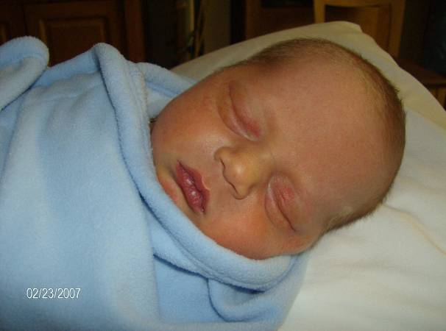

Address
Financial support can be sent to this address:
Cross Road MBC
c/o John Nowlin
111 Ashley 391
Crossett, AR 71635

In the grace of our Lord and Savior, Jesus Christ,

Paul Breshears – Missionary Pastor of East Gate MBC
Our Website: www.eastgatembc.com
Sponsored by Cross Road MBC – Crossett, AR

Beginning Balance |  |  |  | $11,125.64
Contributions
Antioch MBC - Van Buren, AR |  | $175.00
Pleasant Ridge MBC - Rison, AR |  | $250.00
Egypt MBC - Hamburg, AR |  | $500.00
Egypt Ladies Aux - Hamburg, AR |  | $25.00
Bartholomew Association Mission Fund |  | $250.00
Crigler MBC - Star City, AR |  | $905.59
New Hope MBC - Rison, AR |  | $125.00
West Crossett MBC - Crossett, AR |  | $233.05
Bartholomew Association Mission Rally |  | $282.00
Cross Road MBC - Crossett, AR |  | $678.97
East Gate Tithes and Offerings |  | $3,829.94
Total Contributions |  |  | $7,254.55
Expenses
Lease payment |  | $1,050.00
Crown Publications - website |  | $29.95
CS Utilities |  | $201.38
Qwest Phone |  | $46.87
Playpen for nursery |  | $56.58
Missions |  | $100.00
Printer Cartridges |  | $62.68
Return shipping for SS materials |  | $16.86
Transfer to Youth fund |  | $9.01
Transfer to Bldg fund (10% of East Gate MBC Offerings) |  | $382.99
Pastor salary |  | $2,748.62
Total Expenses |  |  | ($4,704.94)
Increase/Decrease for month |  |  |  | $2,549.61
Ending Balance |  |  |  | $13,675.25
Building Fund
Beginning balance |  |  |  | $14,109.95
Landmark MBC - Delta, CO |  |  | $116.80
Cross Road MBC - Crossett, AR |  |  | $275.00
Judson MBC - Hamburg, AR |  |  | $130.87
Bartholomew Association Mission Fund |  |  | $250.00
Global Construction - partial cost of development plans |  |  | ($1,000.00)
10% of East Gate MBC offerings |  |  | $382.99
Spare Change Collection - East Gate MBC |  |  | $62.53
Interest |  |  | $0.67
Ending balance |  |  |  | $14,328.81
Youth Fund
Beginning balance |  |  |  | $290.99
Transfer from general fund |  |  | $9.01
Ending balance |  |  |  | $300.00

Attendance: SS – 19, SM – 19, SE – 17, WE – 12

