Apology
First, I want to start by apologizing for not sending a report for September. October was very busy and I came down with pneumonia during the month which was very uncomfortable and made it hard to get much accomplished. Thank the lord, I am feeling much better now. We also traveled down to Arkansas to visit our sponsoring church. I had planned to visit with a few of the churches that support us but my bout with pneumonia changed my plans.

New Member
We were so thankful that the Lord answered our prayers regarding Shane Weingardt in September. Shane and Kara moved here from Sterling a few month’s ago. Kara has been a member of East Gate since the beginning but was away at college and then living in Sterling for a while. We’ve been praying that the Lord would lead Shane to join the church and he was baptized September 23rd! This was the first baptism in our new location! We are looking forward to watching and being a part of Shane’s walk with the Lord as part of this church. He has already been a blessing to us. Here are some pictures of his baptism.

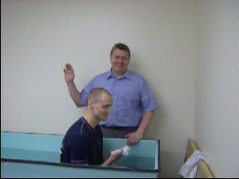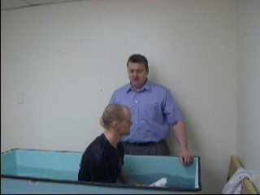

Friends of East Gate
I learned recently that North Loop Baptist Church of Crockett, TX has decided to begin supporting us. Although I have not been able to visit with the people of North Loop, yet, I do know their pastor Bro. Dennis Lowery. Bro. Dennis, and his wife Sis. Cindy, are dear friends of ours and were very involved in the early stages of the work here as well as the early parts of my ministry. I look forward to the time when I can thank North Loop in person and to fellowship with these friends. Thank you, North Loop, for your support and all of your prayers on our behalf. I trust and pray that the Lord will bless you for your faithfulness. As always, we appreciate all of the churches and individuals who have helped the work here in Colorado Springs. As of 2005, Colorado Springs is listed as the 49th largest city in the U.S. but there are only 2 ABA churches here. Certainly, I feel the work is needed in this city and the Lord can and will receive glory from East Gate as long as we allow Him to retain his rightful position. Please pray for us and the city of Colorado Springs.

Address
Financial support can be sent to this address:
Cross Road MBC
c/o John Nowlin
111 Ashley 391
Crossett, AR 71635

In the grace of our Lord and Savior, Jesus Christ,

Paul Breshears – Missionary Pastor of East Gate MBC
Our Website: www.eastgatembc.com

Beginning Balance |  |  |  | $7,481.85
Contributions
Wagonwheel MBC - Henderson, NV |  | $100.00
Antioch MBC – Van Buren, AR |  | $97.09
Egypt MBC - Hamburg, AR |  | $500.00
Egypt MBC, Ladies Auxiliary |  | $25.00
Bartholomew Association Mission Fund |  | $250.00
Bartholomew Association Surplus |  | $1,200.00
South Crossett MBC - Crossett, AR |  | $50.00
New Hope MBC - Rison, AR |  | $125.00
West Crossett MBC - Crossett, AR |  | $341.47
Cross Road MBC - Crossett, AR |  | $582.50
Pleasant Ridge MBC - Rison, Ar |  | $125.00
Calvary MBC - Aurora, Co. |  | $331.55
Refund from Baptist Bookstore |  | $79.52
East Gate Tithes and Offerings |  | $2,507.64
Total Contributions |  |  | $6,314.77
Expenses
Lease payment |  | $1,800.00
Crown Publications - website |  | $29.95
CS Utilities |  | $83.34
Qwest Phone |  | $47.41
Missions |  | $100.00
JC Penney Gift Card For Pastor |  | $100.00
Kelly Lilley / classroom materials |  | $26.02
Sylvia Pool / stamps |  | $6.21
Baptist Book Store |  | $146.46
Transfer to Bldg fund (10% of East Gate MBC Offerings) |  | $250.76
Pastor salary |  | $2,425.60
Total Expenses |  |  | ($5,015.75)
Increase/Decrease for month |  |  |  | $1,299.02
Ending Balance |  |  |  | $8,780.87
Building Fund
Beginning balance |  |  |  | $6,734.78
Cross Road MBC - Crossett, AR |  |  | $150.00
Landmark MBC - Delta, CO |  |  | $91.45
Bartholomew Association Mission Fund |  |  | $250.00
Loan Payment - First State Bank Crossett, AR |  |  | ($422.43)
10% of East Gate MBC offerings |  |  | $250.76
Spare Change Collection - East Gate MBC |  |  | $19.03
Interest |  |  | $0.05
Ending balance |  |  |  | $7,073.64
Youth Fund
Beginning balance |  |  |  | $300.00
Oriental Trading |  |  | ($54.64)
Oriental Trading |  |  | ($35.79)
Dollar Tree |  |  | ($42.79)
Ending balance |  |  |  | $166.78
Attendance: SS – 14, SM – 14, SE – 14, WE – 15

