Let Your Light So Shine
Let Your Light So Shine
~Matthew 5:19

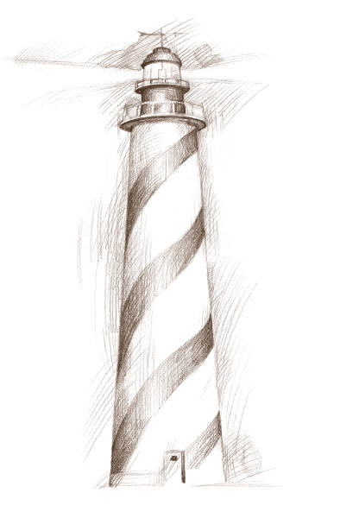
LET YOUR LIGHT SO SHINE
Let Your Light So Shine
~Matthew 5:19
Let Your Light So Shine
~Matthew 5:19

