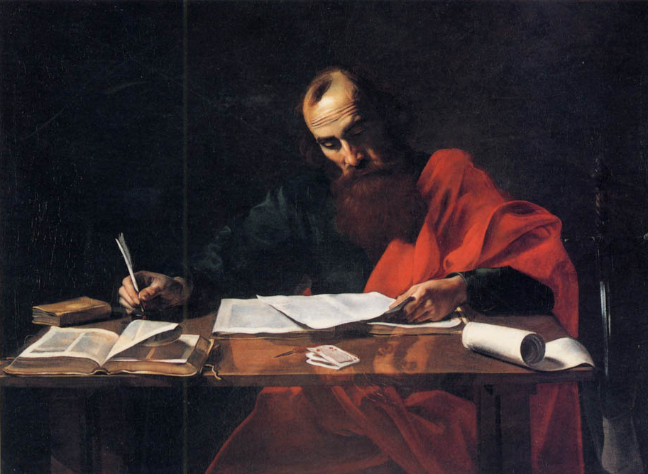
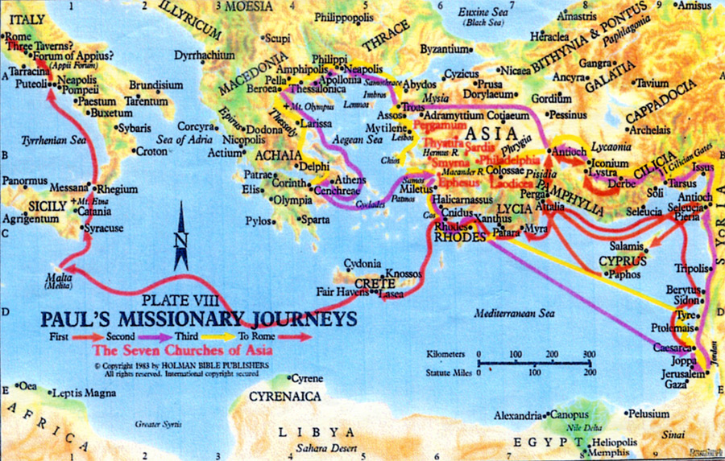
WEEK ONE - PHILIPPIANS 1 - 2:11

Philippians 2:3-4
"Let nothing be done through strife or vainglory; but in lowliness of mind let each esteem other better than themselves. Look not every man on his own things, but every man also on the things of others."

THE THINGS I WANT TO ACCOMPLISH THIS WEEK!!!!
I COR. 10:31

Date: Time:
Weekly Memory Verse - Phil. 2:3-4
Read - Phil. 1: 1-6

Examine -
1. Who wrote this book?
2. Who is with him?
3. What did they call themselves?
4. To whom was this book written?
5. Define Bishop -
6. What two words does he use to greet them?
7. Look at the opening of Ephesians. Is there any difference?

8. What does Paul do when he thinks of the people at Philippi?

9. How often does he pray for them?
10. For what is he so thankful? (vs. 5)
11. In what is Paul confident?

Apply -
When you think of others, does it cause you to pray or gossip or look down on them?

How often do you pray for others?
Make a prayer list of people you would like to pray for and do it!

Main thought to meditate on today:
Date: Time:
Weekly Memory Verse - Phil. 2: 3-4
Read - Phil. 1: 7-13

Examine -
1. Why did Paul always think of the church?
*Do you often think of people that you love?
2. Where is Paul now according to the middle of verse 7?
3. Why was Paul in prison?
4. What was Paul's prayer for these people?
5. What were they to approve?
6. What were they to be until the day of Jesus Christ?

7. With what were they being filled?
8. Why were they filled with these things?
9. All the things that have happened to Paul have done what for the Gospel?
10. Where was Paul now able to preach? (See if you can be specific)

Apply -
We see that Paul is in prison but that he is excited about what is happening all around him. How do you respond to bad situations?
List one bad situation and how you responded.

Now list how you could have responded. (If you responded right, then how could it have been bad and vice-versa)

Paul could have allowed himself to complain and gripe but he did not. He concentrated on the Lord and used bad circumstances to serve Christ. Ask God to help you take bad circumstance and make good out of it!
Main thought to meditate on today:

Date: Time:
Weekly Memory Verse - Phil. 2: 3-4
Read - Phil. 1: 14-19

Examine -
1. We learned yesterday that Paul was able to witness in the palace at Rome. What was another result of his imprisonment?
2. What were the two ways people were preaching Christ?

3. Why does the one preach with contention?

4. Why does the one preach with love?

5. Did it matter to Paul how they preached?
6. What was his attitude about this?
7. Paul was confident that he would be delivered. What two reasons does he give for this confidence?

Apply -
Are you confident to preach the Gospel? You say I can't preach. The word “preach” is to proclaim! All of us can do that, are you?
Purpose to share the Gospel with someone today.

Main thought to meditate on today:
Date: Time:
Weekly Memory Verse - Phil. 2: 3-4
Read - Phil. 1: 20-26

Examine -
1. What is expectation and hope?
2. In what did he want to be bold?
3. Did it matter to Paul whether it was by life or death?
4. If he lived it was .____________
5. If he died it was .____________
6. If he lives in his flesh, what does he get?
7. Does Paul know what to choose?
8. What were the two things Paul was in-between?

9. In what was Paul confident?
10. What were the two things he would help them with if he stayed?
11. In what would the people rejoice?

Apply -
None of us like to die, but Paul was so close to God that he wanted to go be with Him. He also wanted to stay with the saints. Can you honestly say verse 21 and mean it?
Ask God to make you a Phil. 1:21 Christian!

Main thought to meditate on today:
Date: Time:
Weekly Memory Verse - Phil. 2: 3-4
Read - Phil. 1: 27-30

Examine -
1. What should their conversation be?
- In the Greek conversation means life style!
2. What is Paul hoping he will hear about these people? (3 things)

3. Define Perdition –

4. What is a token of perdition to some and to others salvation? (Hint - look at the beginning of verse 27)

5. What two things are given to Christians?

6. If Christians are suffering for the cause of Christ on a daily bases, it would be easy to see how they would want to go to Heaven. Were the people at Philippi having this struggle?

Apply -
It is difficult for us to understand the kind of suffering the early church went through for Christ. What kind of suffering have you gone through for Christ?

If you are not suffering for Him something is wrong. (See II Tim. 3:12)
Main thought to meditate on today:
Date: Time:
Weekly Memory Verse - Phil. 2: 3-4
Read - Phil. 2: 1-4

Examine -
1. Finish the statement:
Any in Christ
Any of love
Any of the Spirit
Any and ______________________
2. If these things are true, what does Paul want them to do?

3. How can they do that?

4. How should things not be done?
5. How should things be done?

6. At what should we not look?
7. At what should we look?

Apply -
This is a tough one. Most of us want our way and we look out for #1. This is opposite of the way the Bible teaches. When is the last time you gave up something you wanted for someone else? Write it here!

We need to ask God to help us be "others conscious"! Tomorrow we will look at what attitude Christ had!

Main thought to meditate on today:

Date: Time:
Weekly Memory Verse - Phil. 2: 3-4
Read - Phil. 2: 5-11

Examine -
1. Whose mind are we to imitate?
2. Was Jesus equal to God?
Verse 6 proves this truth!
3. What did Jesus make of himself?
4. What did he become?
5. Whose likeness did he become like?
6. After he became a man, what did he do?
7. What kind of obedience did he have?
8. What kind of death did he have?
9. As a result what has God done for him?
10. What kind of name does he have?
11. What will happen when people hear the name of Jesus?
1.
2.
12. What three groups of things will bow?

13. What will they confess?
14. For what purpose will they confess these things?

Apply -
This is going to be a powerful scene one day when all creation bows before our LORD! Do you have the mind set that Christ had when he came to this earth? Have you already made him the LORD of your life? Ask God to help you everyday to bow before him in submission! Specifically name an area you need help with.
Main thought to meditate on today:

WEEK FOURTEEN - PHILIPPIANS 2:12 - 3:21

Philippians 3: 13-14
"Brethren, I count not myself to have apprehended: but this one thing I do, forgetting those things which are behind, and reaching forth unto those things which are before, I press toward the mark for the prize of the high calling of God in Christ Jesus."

THE THINGS I WANT TO ACCOMPLISH THIS WEEK!!!!
I COR. 10:31

Date: Time:
Weekly Memory Verse - Phil. 3: 13-14
Read - Phil. 2: 12-17

Examine -
1. What complement did Paul give these people?
In view of what Paul had already told them in Chapter 2 (the word wherefore indicates this), they were to work out their salvation. This does not mean to work for their salvation. As a result of them being saved they were to prove their salvation through working. In the context they must have been fighting a lot among themselves.

2. How were they to work out their salvation?

3. Who really is working in them?
4. What is God doing?
5. How were they to do all things?
6. What were they to be to the people around them? (Three things)

7. How did Paul describe the nation where they lived?
8. What were they to hold forth?
9. Why did Paul want them to stick it out?
10. Paul was probably going to die very soon. This is partly because he preached the Gospel at Philippi. If the church there did their sacrifice and service by faith, Paul would what?

Apply - We are in a perverse and crooked generation as well. We are not that different from this church. Are you blameless, harmless and without rebuke?

Are you a shining light to those around you? Name one way you could be that today and purpose to do that.
Ask God to make you the person you should be! As you grow towards Christ likeness I will rejoice as well!
Main thought to meditate on today:
Main thought to meditate on today:
Date: Time:
Weekly Memory Verse - Phil. 3: 13-14
Read - Phil. 2: 18-24

Examine -
1. In what do they rejoice?
2. Who is Paul hoping to send to them?
3. Why was he sending Timothy?
4. How will Timothy care for the people?
5. How do most people respond? (Vs. 21)

6. Are you a Phil. 1:21 or 2:21 Christian?
7. What relationship does Paul compare to Timothy and his?

8. When is Paul planning to send him to them?
9. What else was Paul hoping to do?

Apply -
Are you as trust worthy as Timothy? What are you seeking?
Read Matt. 6:33. Make this your prayer this morning and ask God to remove those things that you are seeking for yourself. List those here and make them a daily prayer!

Main thought to meditate on today:
Date: Time:
Weekly Memory Verse - Phil. 3: 13-14
Read - Phil. 2: 25-30

Examine -
1. Who was Paul sending until Timothy could arrive?
2. What three ways did Paul describe him?

3. What was he to the church? Why?

4. How did Epaphroditus feel about the church?
5. Why did this seem to be true?
6. How sick was he?
7. How did he get better?
8. How did Paul send him to Philippi?
9. How should they receive him?
10. How should they treat him?
11. Why should they treat him this way?

Apply -
Paul spends a great deal of time in this chapter on two men and what they meant to him. One was willing to die for the cause of Christ. This is a rebuke to us. List what you are willing to give up for Christ?

Is there anything you are not willing to do?

Main thought to meditate on today:
Date: Time:
Weekly Memory Verse - Phil. 3: 13-14
Read - Phil. 3: 1-6

Examine -
1. Count the number of times Paul uses the word joy, rejoice, or some form of these words. times.
2. What is safe for the people at the church?
3. Paul uses the word beware three times. List the things of which he told them to beware.

Explanation: In those days there was a group of people that tried to convince the people that they needed to observe the law as well as accept Jesus to be saved. They were called Judizers. There were different forms of this but this is what they primarily believed. All three of “the bewares” are names given to this group of people. One of the primary controversies was circumcision. Paul was circumcised but was not counting on this to save him. He had "...no confidence in the flesh." This literally means what the flesh could do.

4. If anyone could have had confidence in the flesh, who was at the top of the list?
5. List the right answer beside the word:
Circumcised -
Tribe of -
Touching the Law -
Concerning zeal -
Righteousness in the law -

Apply - Paul proves in this passage that no matter how good we think we may be our goodness is nothing! Paul was as righteous as anyone yet he needed Jesus. Do you verbalize your need of God to Him? When is the last time you thanked God for your salvation!
Main thought to meditate on today:
Date: Time:
Weekly Memory Verse - Phil. 3: 13-14
Read - Phil. 3: 7-12

Examine -
1. What things did Paul lose for Christ?
2. For what did he lose these things?
3. What did he count these things?
4. Define Dung -
5. Did Paul have any of his own righteousness?
6. Whose righteousness did he have?
7. How did he get it?
8. Who did Paul want to know?
9. List the three areas that Paul wanted to know him?

10. Verse 11 could be referring to the resurrection but we really are not sure. Paul reminds the believers that he had not yet attained the things he mentioned in verse 10. He also was not
.
11. Although Paul had been saved approximately 30 years, was he still trying to grow?

Apply -
What about you, do you want to grow or do you know it all?
List some areas in which you need to grow.
Do you really know God? Could you describe Him from personal experience? Ask God to teach you about Himself through personal experience!
Main thought to meditate on today:

Date: Time:
Weekly Memory Verse - Phil. 3: 13-14
Read - Phil. 3: 13-17

Examine -
1. What is the one thing that Paul does?
2. What is Paul pressing towards?
3. How are we perfect?
4. If this is true, about what should we be thinking?
5. Should we have our mind on any other thing?
6. By what rule should we walk?
We should be focused on pleasing God in our mind and in our walk.
7. Who did Paul tell them to follow?
8. Who should we mark?

Apply -
To be double minded is unstable. (Jas. 1:8) We are to have a single focus. Write your focus for life here! If you don't have one, ask God to give you one!

Also write how you plan to work toward your focus, now, in your teen years.

Main thought to meditate on today:
Date: Time:
Weekly Memory Verse - Phil. 3: 13-14
Read - Phil. 3: 18-21

Examine -
1. Some people who are walking are what?
2. How does Paul tell these people this?
3. What is their end?
4. Who is their god?
5. In what do they glory?
I believe these three things represent the list of the flesh, lust of the eyes and the pride of life.
6. On what is their mind?
7. What should our life reflect?
8. For whom should we look?
9. What will God do when he comes to get us?
10. What will our body be like?
11. What is Christ able to subdue?

Apply -
How do you walk? Does your talk match your walk?
Are you looking for Christ to change your body?

Main thought to meditate on today:
WEEK ONE - PHILIPPIANS 4

Philippians 4: 4-6
"Rejoice in the Lord always: and again I say, rejoice. Let your moderation be known unto all men. The Lord is at hand. Be careful for nothing; but in every thing by prayer and supplication with thanksgiving let your request be made known unto God."

THE THINGS I WANT TO ACCOMPLISH THIS WEEK!!!
I COR. 10:31

Date: Time:
Weekly Memory Verse - Phil. 4: 4-6
Read - Phil. 4: 1-4

Examine -
1. What does he use to describe the believers? (Used twice)

2. What were they to Paul? (2 things)

3. How were they to stand?
4. Define Fast - (use the definition you think fits best)

5. What two ladies are mentioned here?
6. What did he tell them to do?
7. What do you think they were doing?
8. Define Yokefellow -
9. What did he tell his yokefellow to do?
10. What are we to do always?
11. In what are we to rejoice?

Apply -
Paul is encouraging everyone to be on the same page. Are you on the same page with those with whom you minister? Ask God to give you like-mindedness!
Do you always rejoice and is it in the Lord?
All of us could use improvement in this area! List some good and bad things you can rejoice in today!

Main thought to meditate on today:

Date: Time:
Weekly Memory Verse - Phil. 4: 4-6
Read - Phil. 4: 5-9

Examine -
1. Define Moderation -
2. Who should know about their moderation and why?
3. The word careful here means worry. What should we worry over?
4. What is our alternative for worry?
5. There are four words here that describe pray: Define them!
Pray -
Supplication -
Thanksgiving -
Request –
You may need help on this one. If so, contact me – 704-418-0124
6. How does Paul describe the peace of God?
7. What will this peace do for us?

8. Briefly give a definition to the things we are to think on:
True -
Honest -
Just -
Pure -
Lovely -
Good report -
9. List the four ways Paul taught people?
10. What were they to do with what they had learned?
Apply - Paul deals with a lot in this brief passage! He teaches us how to pray, think and act. In light of these things how would you evaluate these things in your life? Write them out with an explanation on the another sheet!
Main thought to meditate on today:
Date: Time:
Weekly Memory Verse - Phil. 4: 4-6
Read - Phil. 4: 10-14

Examine -
1. If we look back to the end of chapter two, we see that maybe this church had not cared for Paul as they should. Read that verse. Paul uses the phrase "lack of service". Now look at verse 10, have things changed?
2. Could the problem have been that they did not know how? (Look at the last part of verse 10)
3. Did Paul want something?
4. What valuable lesson had Paul learned?
5. In what two states did Paul know how to be?
6. It seems like every place Paul went he had both sides of this coin. Can he do these things?
7. How can he accomplish these things?
8. What does he mean in verse 14?

Apply -
Paul learned to have a lot and have nothing. Those are two contrast and most of us struggle to handle one side of this coin. I know some of us would like to try the "abound" side. Have you thought that maybe God has not let you do that because you have not been content with what He has given you? No matter where you are today thank God and ask Him to make you content!

Main thought to meditate on today:
Date: Time:
Weekly Memory Verse - Phil. 4: 4-6
Read - Phil. 4: 15-19

Examine -
1. How many churches gave to Paul on this journey?
2. When he was at Thessalonica, how many times did they help him?
3. If you can tell me what missionary journey this was on and offer proof, it will be rewarded.
4. Did Paul want a gift?
5. Why did Paul want them to give?
6. Fruit indicates growth, so does this mean that our growing spiritually could be connected to our giving?
Explain:
7. In verse 18 on what side of our coin, we talked about yesterday, is Paul now?
8. Who brought the things from the church?
9. Who, besides Paul, is pleased with the gift?
10. What will God do for us?
11. This is promised to a church that just ministered to Paul. Do you think your giving is connected to God's supplying?
12. What are His riches in glory like?

Apply -
Giving is an important part of the Christian life. We not only should give ourselves but our money as well. When is the last time you gave up something to give to someone else? Ask God to make you a giver!

Main thought to meditate on today:

Date: Time:
Weekly Memory Verse - Phil. 4: 4-6
Read - Phil. 4: 20-23

Examine -
1. Who is to get our glory and for how long?

2. Did Paul have people with him?

3. What stands out to you about verse 22? (Look also at Phil. 1:13)

4. Why is this important?

5. If God puts you in a tough situation, is that an excuse to not live for Him?

Apply -
We know the answer to the above question but many times applying it is a different story. Ask God to help you witness to someone today!
If you don't go to a public school, you still can witness but also pray for those who do, they have a tough time standing!

Main thought to meditate on today:
Date: Time:
Weekly Memory Verse - Phil. 4: 4-6
Read - Phil. 1-2

Examine - In your own words write a brief statement of what you feel each chapter is saying.
Chapter 1 -

Chapter 2 -

Apply -
Write the things that God spoke to your heart out of chapters one and two!

Main thought to meditate on today:
Date: Time:
Weekly Memory Verse - Phil. 4: 4-6
Read - Phil. 3-4

Examine -
Write a small paragraph explaining what Paul was trying to say in these chapters!!!

Apply -
How does this book help you in your Christian life? Write some specifics!

List the truths that you can be most thankful from this passage!
Main thought to meditate on today:

Prayer:
Praise:

