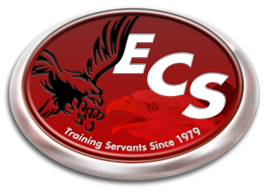ECS 2015-2016 School Calendar

August 3rd-6th - Teacher Work Week

August 6th - Teacher/Parent Meeting – 6:00 pm

August 7th - First Day of School

September 7th - Labor Day Holiday

October 6th - School Portraits

October 9th - End of First Quarter

October 16th - Teacher Training in TN.

November 23rd-27th - Fall Break

December 18th  - End of Second Quarter

Dec. 21st-Jan. 1st - Christmas Break

January 4th - School Resumes

January 18th - Martin Luther King Jr. Holiday

February 15th - President’s Day Holiday

March 4th - End of Third Quarter

March 7th-11th - Spring Break

March 28th – March 31st - Standardized Testing Week

*(school out at 12 pm each day)*

April 8th - Sports Banquet

May 3rd - Awards Banquet (6 pm)

May 6th - Kindergarten Graduation (6 pm)

May 13th - Last Day of School

High School Graduation (6 pm)

*\*Underlined Dates denotes “No School”*

*\*Schedule is tentative and subject to change is something arises that would cause it to.*