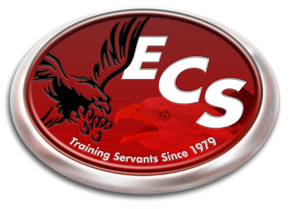ECS 2014-2015 School Calendar

August 4th-7th - Teacher Work Week

August 7th - Teacher/Parent Meeting – 6:00 pm

August 8th - First Day of School

September 1 - Labor Day Holiday

October 7th - School Portraits

October 10th - End of First Quarter

October 17th - Teacher Training in TN.

November 24th-28th - Fall Break

December 19th  - End of Second Quarter

Dec. 22nd-Jan. 2nd - Christmas Break

January 5th - School Resumes

January 19th - Martin Luther King Jr. Holiday

February 16th - President’s Day Holiday

March 6th - End of Third Quarter

March 9th-13th - Spring Break

March 31st – April 2nd - SAT Testing Week

*(school out at 12 pm each day)*

April 3rd - Good Friday Holiday

May 5th - Awards Banquet (6 pm)

May 8th - Kindergarten Graduation (7 pm)

May 15th - Last Day of School

High School Graduation (7 pm)

*\*Underlined Dates denotes “No School”*

*\*Schedule is tentative and subject to change is something arises that would cause it to.*