Kenya 2025 ***“The half has not been told!”***

***I Kings 10:7; II Chronicles 9:6***

12/28/24 Nairobi Hotel and street 28

12/29/24 FBC Mahianyu 42(adult) 14(youth service) saved

12/30-31/24 Great Hope Children’s Home-Nakuru:youth camp over 100 kids(44 orphans) 5 saved

—-Faith Bible Baptist Church New Year service: 6 saved

1/1/25 Nakuru Prison 1800men (250plus saved); 84 women (30 saved)

1/2/2025 Kitale 24,Pastors OperationGo: 15 children saved

1/3/25 Van in shop; travel to Nakuru 18 saved

1/4/25 home visits; 16 saved

1/5/25 Kiarie’s Church 7 baptisms

1/6/25 first Masai Church 16 saved

1/7/25 Masai village 35 saved

TOTAL 475 saved

**Faith Baptist Church**

808 Rives Street

Charlottesville, VA 22902

**Mailing Address: P.O. Box 6343 Zip: 22906**

434-977-7128

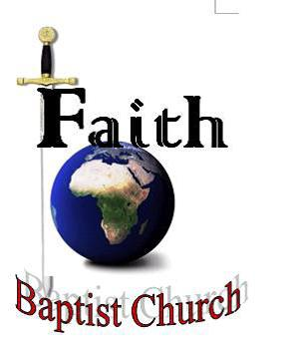

**G. Raye Jones, Pastor**

www.faithbaptistchurchcharlottesville.com

“Where people and God are loved and you will experience God's grace and mercy"