REVIVAL

Maranatha Baptist Church

September 9 – 14, 2012

Sunday – 11am & 6:30pm

Monday – Friday – 7:00pm

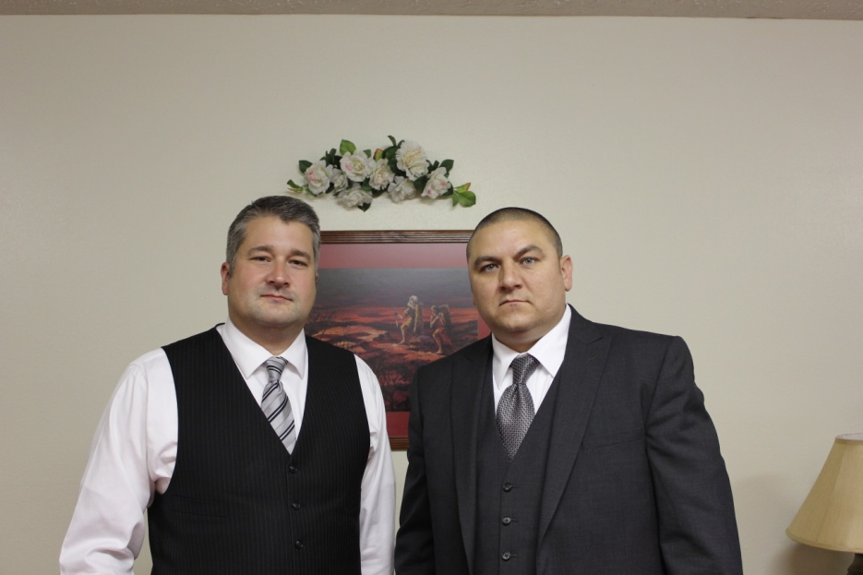

Dale Vance, Sun-Wed

Barry Spears, Thurs-Fri

Visit our website: [www.mbcwva.com](http://www.mbcwva.com)

REVIVAL

Maranatha Baptist Church

September 9 – 14, 2012

Sunday – 11am & 6:30pm

Monday – Friday – 7:00pm



Dale Vance, Sun-Wed

Barry Spears, Thurs-Fri

Visit our website: [www.mbcwva.com](http://www.mbcwva.com)