

*For additional copies or MS Word file copy contact:*

New Testament Baptist Church

2501 S. 1st Ave; Safford, AZ 85546

928.428.6571 ● info@ntbcsafford.org

Missions Conference

Song Book



*“And he said unto them, Go ye into all the world, and preach the gospel to every creature.” (Mark 16:15)*

Who Will Pray?

-Peter Davis

Who will pray for us who go,

Bearing precious seed to sow:

Who will pray that all may know?

Who will pray? O, who will pray?

Who will pray for those we win,

Those we free from chains of sin,

Nevermore to live therein?

Who will pray? O, who will pray?

Who will plead for sinners lost?

Jesus paid their bitter cost:

We both land and sea have crossed:

Who will pray? O, who will pray?

As we open lands unknown,

Oft in perils, poor, alone,

Who will name us at the throne?

Who will pray? O, who will pray?

We will go, though fraught with fears:

Though we spend our finest years,

Gladly we are volunteers:

(But) who will pray? O, who will pray?

See them perish day by day:

One by one they slip away:

Intercede! Make no delay!

Who will pray? O, who will pray?

…An artist was once asked to portray a dying church. To the astonishment of many, instead of depicting an old tottering ruin, the artist painted a stately building of modern grandeur. Through the opened stained glass windows could be seen the richly carved pulpit and expensive organ. Just within the grand entrance, guarded by parishioners in spotless apparel and glittering jewelry, was an offering plate of excellent workmanship. The artist’s conception of a decaying church, though subtle, was revealed in a square box suspended from a nail in the wall. Simple letters painted on the box bore the message:

“Collection for Foreign Missions”

Covering the slot through which the contributions should have been deposited, there was a huge cobweb...

It’s a matter of obedience…

*“…according to the commandment of the everlasting God, made known to all nations for the obedience of faith:” (Romans 16:26)*

19. Where Heathen Dwell

Tune: “There is a Fountain”

*(Repeat as required for chorus)*

Where heathen dwell in dark despair,

And under judgment’s doom,

*Both joy and peace become so rare,*

*That hope can never bloom.*

They bow their hearts to Satan’s lash,

And feel his painful stings,

*While round them superstitions clash,*

*And mocking laughter rings.*

Though they may look for fond relief,

To set their hearts at ease,

*They daily drink the dregs of grief,*

*And sorrows never cease,*

But there’s a fountain filled with blood,

If they but knew its power,

*That sinners plunged beneath that flood,*

*Find peace that very hour.*

Lord Jesus, I will not refuse

Thy Will, or Thy Control,

*That souls may hear the joyful news,*

*That Christ can make them whole.*





1. They Must Know

Tune: “To God be the Glory”

To this world of sorrow a Saviour was sent,

And God gave His promise to those who repent,

But millions have never this promise believed,

Because they have never this message received.

Chorus:

They must know, they must know of the Saviour’s great Name,

We must go, we must go and the Gospel proclaim.

Come, Go to the nations with His Word of love

And tell them the Saviour came down from above.

To souls still in darkness, Christ’s death is in vain,

And His resurrection brings their lives no gain,

So millions are standing and looking our way.

“Oh, tell us of Jesus” they pleadingly say.

Some day up in Glory, We’ll face our great King,

And songs of rejoicing around us will ring;

But some who have never obeyed His commands,

Will stand there before Him with blood on their hands.

2. Oh, Lord My God

Tune: “How Great Thou Art”

Oh, Lord my God, I think of Millions dying

Without a ray of hope or Gospel light.

I come to give, my life forever trying

To bring them from the curse of endless night.

Chorus:

My heart cries out, my Saviour God to Thee,

Oh, let me go, that they might know.

My heart cries out, my Saviour God to Thee,

Oh, let me go, that they might know.

Oh, Lord my God, when I consider Jesus,

And all the grief and sacrifice He bore,

And how He breaks our chains of sin and frees us,

From Satan’s bonds, it stirs me to the core.





18. One Day the Saviour Ascended

Tune: “One Day”

One day the Saviour ascended to Heaven.

One day He told us His Word to proclaim.

“Go to the world making known My salvation.

Make every lost one to know My Name.”

Chorus:

Living He loved me, dying He saved me,

But, then, He sent me His word to proclaim.

I will renounce the world, and I will witness

Tell out the good news in our Saviour’s Name.

Jesus commanded His servants to witness,

“Give out the Gospel where no one has preached.”

But we have settled in places of comfort,

Telling the message to those who’ve been reached.

Many long years He has left us to witness,

But until now we’ve not fully obeyed.

We must rise quickly, and go out to tell them

That all their sin debt He fully paid.

17. He Has Called Us

Tune: “Face to Face”

Face to face with Christ my Saviour,

Face to face, what will it be?

When I answer to my Master,

Jesus Christ Who died for me.

Chorus:

Face to face I shall behold Him

On His glorious judgment seat.

What a shame, if at that meeting,

I lay nothing at His feet.

He has called us to the reaping,

Urgently sent out the call.

What a shame, if at His coming,

We have brought no sheaves at all!

Face to face, what tragic moment,

When with sorrow in His eyes,

All my works burned in a moment,

What a woeful paradise!





3. If They Never See The Light

Tune: “At the Cross”

Praise God, and since my Saviour bled,

And since my Sovereign died,

I’ll go and do what Jesus said,

And take Him as my Guide.

Chorus:

Oh, what loss oh, what loss,

If they never see the light,

And if no one takes their burdens all away,

If the heathen die, in the gloom of sinful night,

If they never know a single happy day.

See, then, it’s written in His Word,

The workers are so few.

Why do we call the Saviour “Lord”.

But fail His work to do?

Is it not now my daily task.

To seek His word to do?

How can it be too much to ask.

When laborers are so few?

4. Out in The Darkness

Tune: “I Must Tell Jesus”

Out in the darkness, lost ones are waiting,

Waiting for light, salvation, and love.

They do not know that Jesus will save them,

That He’ll receive them home up above.

Chorus:

Oh, we must tell them. Yes, we must tell them.

We must not let them perish in vain.

Oh, we must tell them. Yes we must tell them.

Hell to avoid, and Heaven to gain.

They can’t tell Jesus all of their trials,

They must endure their burdens alone

No one has told them of His salvation,

That He has died their sins to atone.

Why do we linger, why do we tarry?

Now is the time to show them the way.

If we delay, they surely will perish.

We must be busy even today.





16. I’ll Give Myself

Tune: “Amazing Grace”

Amazing grace how sweet the sound,

To those who know the Lord,

But what of those who still are bound

And do not have His Word!

The many dangers, toils, and snares,

Through which we daily go,

Are nothing much when they compare

With what the heathen know.

Ten thousand years to sing His praise,

Bright shining as the sun,

While lost men suffer endless days,

Their torment never done,

Since grace has meant so much to me,

What would it mean to them?

I’ll give myself, oh, Lord, to Thee,

To bring Thy grace to them.

15. We’re Spreading The Gospel

Tune: “We’re Marching to Zion”

Come ye that love the Lord,

And let God’s Word be known.

Involve your life to preach God’s Word. (Repeat)

And so make Jesus known,

And so make Jesus known.

Chorus:

We’re spreading the Gospel

Telling the Gospel of Jesus,

We’re teaching and preaching the Good News,

As we’ve been commanded to do.

Let those refuse to go,

Whose hearts are hard and cold,

But millions that have never heard, (Repeat)

Will never once be told.

Will never once be told.

Then go out everywhere,

And may all lost ones be told,

That Jesus paid redemption’s price, (Repeat)

Because He loves them so,

Because He loves them so.





5. When I See The Host

Tune: “When I See the Blood”

Christ our Redeemer died on the cross.

Died for the sinner, paid all his due

Yield Him your life, be quick to obey.

Harvest is late, the laborers are few.

Chorus:

When I see the host,

Of those who are lost.

I can then count the cost,

And my heart yearns to tell them of Christ.

Chiefest of sinners Jesus will save,

All He has promised that I will do.

Go with the Gospel, go, give, and pray.

Harvest is late, the laborers are few.

6. I know He’s Wonderful

Tune: “His Name is Wonderful”

I know He’s wonderful, you know He’s wonderful,

We know He’s wonderful, Jesus our Lord.

But some have never heard, have never known His Word.

Their souls been never stirred, Oh, think of that!

Chorus:

Let us obey Him, go to the heathen,

Oh, how He longs for them.

Nought should prevent us,

For He has sent us

To those who’ve never heard in every land.

We know He came to die, we know He lives on high

We know He’ll come again, Jesus our Lord

But some have never known all that our God hath done,

Through His eternal Son, Jesus our Lord.

We’ll seek each fallen one. Tell them what God hath done,

Through His eternal Son, Jesus our Lord.

All lands shall know His name, and why it was He came,

To take their sin away, Jesus our Lord.





14. Hear the Blessed Saviour

Tune: “Come Unto Me”

Hear the blessed Saviour calling unto you,

“Oh, ye saved and happy—there is work to do.

Go ! No longer tarry, I have sent you there

With the Gospel message, go out everywhere.”

Chorus:

Go out today, I have sent you there.

Take the Gospel message, Go out everywhere.

Surely I am with thee, Go and trust My might,

To those souls in darkness, take the Gospel light.

Is your life a failure, giving you no joy?

Give it to The Master, work in His employ.

He will use you daily, witnessing for Him.

Then you will be happy, more than you have been.

Have you sought for pleasures, from this world of sin,

But you found those pleasures brought no peace within?

Christ will satisfy you, go His work to do,

He has satisfied me, He will please you, too.

13. They Must Know That Jesus Died

Tune: “Take the Name of Jesus with You”

Take the Name of Jesus with you,

Into every heathen land,

For the Saviour did command you,

Make the heathen understand.

Chorus:

They must know Jesus died.

He’s their only hope of Heaven.

They must know Jesus died.

He’s their only hope of Heaven.

Take the Name of Jesus with you,

Minding not what ‘er the cost,

For in Spite of all it costs you,

How much more, if they are lost!

Will I have their blood upon me,

At the Judgment Seat of Christ

Will my shame be there upon me,

For the way I’ve lived my life?



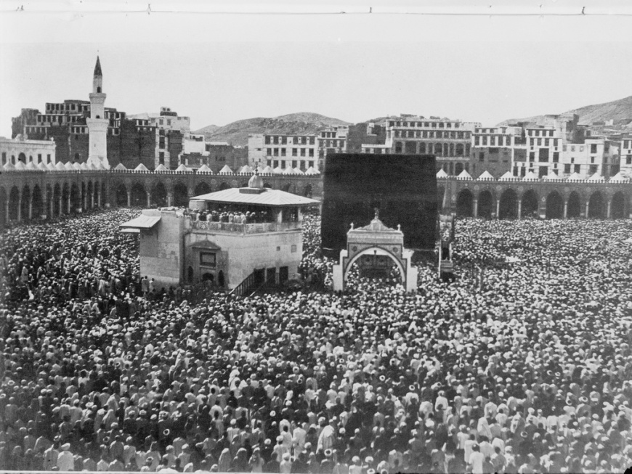

7. In A Land Far Away

Tune: “The Old Rugged Cross”

In a land far away lost souls suffer and die,

‘Neath the lash that the devil controls;

And the demons hold sway as hope withers and dies,

In the hearts of those sin-blighted souls.

Chorus:

So I’ll do as the Saviour commands,

And I’ll go out where evil is rife,

I will go to those sin-blighted lands,

And I’ll give God the days of my life.

Oh, they’ll always be lost in those sin-blighted lands,

Unless Christians will go, give and pray;

For as God has sent Me, even so send I you,

We have heard Jesus pleadingly say.

Unless someone will go, surely they cannot know

That Jesus has died on the tree.

Oh, the cost is too great, if we linger and wait,

To tell them salvation is free.

8. Going Forth To Conquer

Tune: “Standing on the Promises”

Going forth to conquer in the Master’s Name,

Marching forth together with our hearts aflame,

Telling in the byways that the Saviour came,

Doing what the Saviour said to do.

Chorus:

Going, telling, doing what the Master said to do, together,

Preaching, teaching, doing what the Saviour said to do.

Jesus said to teach of Him in every place,

Jesus said to tell the lost of saving grace.

Soon we’ll stand to give account before His face,

Have we done what Jesus said to do?

Many hearts are hungry for the Bread of Life,

Many more are battered by their sin and strife.

We must go where misery and sin are rife,

We must do what Jesus said to do.

Going, telling, doing everything we can,

Showing those in darkness God’s redemptive plan,

Telling how He loves the souls of fallen man,

Doing what the Saviour said to do.

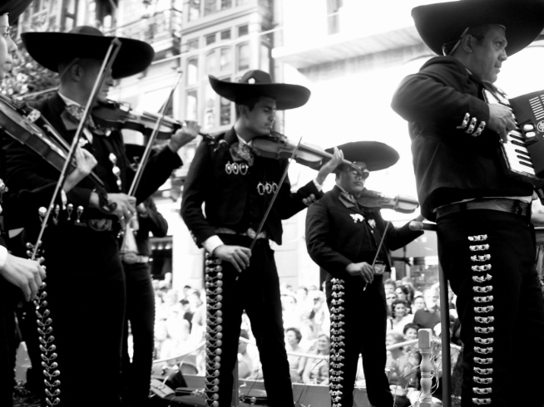



12. God Bless Our Missionaries

Tune: “God Bless America”

God bless our Missionaries

Clothed with Thy love

Stand beside them

And guide them

Give them courage and

Strength from above.

Chorus:

From the cities

To the hamlets

On to villages

Far and wide;

God Bless our Missionaries

May we stand by their side.

11. Every Home

Tune: “Stand Up, Stand Up for Jesus”

Our Lord said, “Every Creature,”

How dare we disobey?

The message must be taken,

Then let us speed away.

The Gospel must be published,

And put in every home,

Oh, hasten then and seek them…

Wherever they may roam.

We may not go in person,

But we can give and pray.

The printed page will tell them,

Of Christ the Truth, the Way.

Then let us put our money,

Where it will count the most.

The MESSAGE is God’s method,

His power—the Holy Ghost.

Within our generation,

The story must be told.

For millions are still waiting,

Outside the Saviour’s fold.

Then let us speed His coming,

By doing what he said.

The multitudes are longing

For Christ—the Living Bread.

9. Give Them The Gospel

Tune: “Tell Me the Story of Jesus”

Give them, Oh, give them the Gospel,

Why should they die in their sin?

Tell them, oh, tell them of Jesus,

They are so burdened within.

Long have they waited in darkness,

Waited for someone to go.

Long have they sought in their blindness.

Jesus the Saviour to know.

Chorus:

Tell them, OH, tell them the story,

The story of Christ crucified;

Point them to Jesus, the Saviour,

The Jesus who suffered and died.

Take them, oh, take them the message,

Why should they longer despair?

Only the Saviour can help them.

Banish their sorrow and care.

Go, then, and tell them of Jesus.

It was for them He was slain.

Give them, Oh, give them the Gospel.

Let not their cry be in vain.



10. Hark The Master Calleth

Tune: “Onward Christian Soldiers”

Hark, the Master calleth.

Who for me will go?

Some from every nation

Must the Saviour know.

Other sheep are waiting,

For the Gospel call;

Ev’ry tongue must praise Him,

Jesus died for all.

Chorus:

Hasten, then, Oh, hasten my brother,

To the lands of night;

Farther and still farther,

With the Gospel light.

Harvest fields are bending,

Soon “twill be too late”

Reapers now are needed,

Lo, tis death to wait

Who will take the Gospel,

Over land and sea;

Who will answer gladly,

“Here am I, send me?”

All may share the glory,

Some can give and pray;

Others at His bidding.

Quickly speed away.

Life must be invested.

None for self may live;

Who will heed the challenge.

All to Jesus give?