Four Horsemen of the Apocalypse   
Revelation 6:1-8

**This is a symbolic vision of the Antichrist as he proceeds through the   
7 years of Tribulation.**

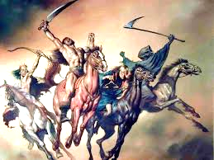

D*eath and Hell are paired here on the pale horse. This unwelcomed rider can be followed through the remainder of the Book of Revelation.* ***If this rider appeared today, he would take more than 1.5 billion souls!***

**DEATH & HELL**

**FAMINE**

*Food shortages naturally follow war. Regimentation of resources is implemented by the Antichrist.*

**WAR**

**‘PEACE’**

A*ntichrist is now exposed as a blood-thirsty warlord. World domination is his agenda.* ***Notice: the rider now has a weapon…a sword!***

A*ntichrist appears on the world stage with a plan for ‘peace’  
(bow with no arrows)*