**“Times of the Gentiles”**

**Daniel 2:31-45  
Nebuchadnezzar’s Dream**Crucial to an understanding  
of the Judgment of the Gentiles

Luke 21:24

[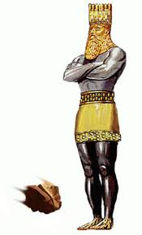](http://www.google.com/imgres?q=nebuchadnezzar+image&start=142&hl=en&sa=X&tbo=d&qscrl=1&rlz=1T4ADRA_enUS433US441&biw=1366&bih=618&tbm=isch&tbnid=q10Q_jqRuQw5PM:&imgrefurl=http://whenintime.com/EventDetails.aspx?e=4566c792-34a0-423a-9c7e-d5f332926cc5&t=/tl/zizzigy/The_Bible/&docid=pYZkm473YkgsoM&imgurl=http://www.thepropheticscroll.org/home/images/stories/nebuchadnezzarsdream1003.jpg&w=242&h=400&ei=JZfPUIquMc-50QGE5ICwBA&zoom=1&iact=hc&vpx=519&vpy=214&dur=1209&hovh=289&hovw=175&tx=96&ty=151&sig=101328043527389429579&page=5&tbnh=142&tbnw=82&ndsp=36&ved=1t:429,r:54,s:100,i:166)

**FEDERATION of NATIONS  
(revived Roman Empire)**

**BABYLON**

**KING of KINGS at His SECOND COMING To put down Gentile rule and establish His everlasting Kingdom of Righteousness**

**ROME**

**GREECE**

**MEDO-PERSIA**

“And the seventh angel sounded; and there were great voices in heaven, saying, The kingdoms of this world are become the kingdoms of our Lord, and of his Christ; and he shall reign for ever and ever.”  
Revelation 11:15