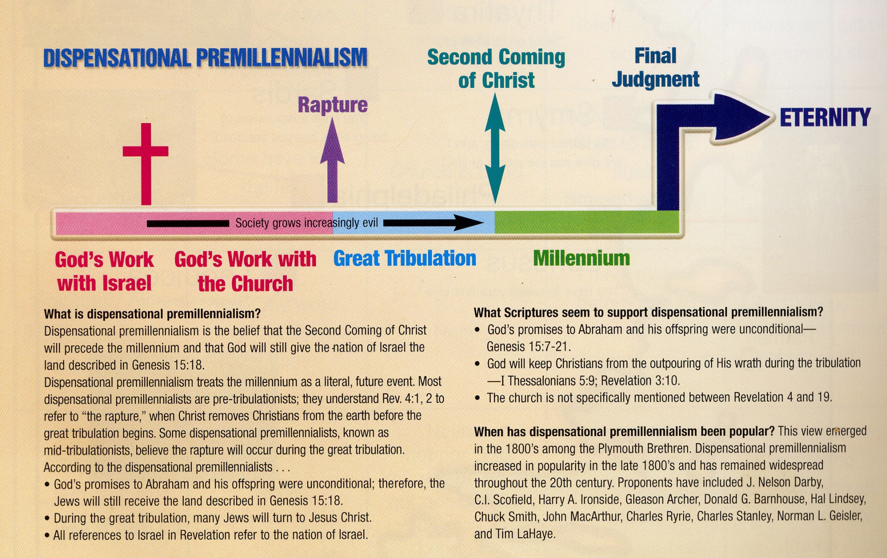

*“Study to shew thyself approved unto God, a workman that needeth not to be ashamed, rightly dividing the word of truth.” -*2 Timothy 2:15