**The J**udgmentof the **G**entiles  
 ***Sheep & Goat Judgment***

**Matthew 25:31-46**

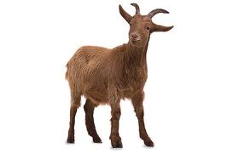

[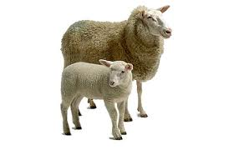](http://www.google.com/imgres?q=sheep+goat+clipart&hl=en&sa=X&qscrl=1&rlz=1T4ADRA_enUS433US441&biw=1366&bih=618&tbm=isch&tbnid=NMtc63IcBcUe-M:&imgrefurl=http://www.clipart.dk.co.uk/685/az/Farm/Sheep_and_lamb&docid=8ptKSm4NbCi79M&imgurl=http://www.clipart.dk.co.uk/DKImages/farm/image_farm001.jpg&w=464&h=298&ei=yb0_Ub6DIs3y0wHil4CYDw&zoom=1&ved=1t:3588,r:20,s:0,i:151&iact=rc&dur=744&page=2&tbnh=171&tbnw=276&start=19&ndsp=28&tx=129&ty=96)



***To aid a Jew during the reign of   
Antichrist is to risk one’s life.***

* ***Those Gentiles that HAVE shown compassion toward the Jews during the 7 years of Tribulation and especially during the last 3 ½ years known as “Great Tribulation”***
* ***These Gentiles will have refused the ‘Mark of the Beast’ and defied  
   the ‘man of sin’***
* ***ADMITTED INTO THE KINGDOM***

**Keys to Understanding this Judgment**

* *This is* ***NOT*** *the Judgment Seat of Christ (for believers)*
* *This is* ***NOT*** *the Great White Throne Judgment (for unbelievers)*
* *This is* ***NOT*** *a judgment of works--this IS a judgment of faith  
  the works of the sheep merely evidence their faith (‘faith without works is dead’)*
* *This Judgment occurs on Earth* ***AFTER*** *Tribulation and* ***BEFORE*** *the Millennial Kingdom*



[](http://www.google.com/imgres?imgurl=http://sweetclipart.com/multisite/sweetclipart/files/red_yellow_fire_logo.png&imgrefurl=http://sweetclipart.com/red-and-yellow-fire-logo-408&h=7399&w=5084&sz=1145&tbnid=hRUslc-JOL5ftM:&tbnh=90&tbnw=62&prev=/search?q=fire+clipart&tbm=isch&tbo=u&zoom=1&q=fire+clipart&usg=__aUf7m_G0Y6xVURvH7ctuk6kSvcI=&docid=zUL8NJ1kyJtliM&hl=en&sa=X&ei=IDouUYzXKK620AGl2oGACg&ved=0CDsQ9QEwBA&dur=1160)

**BLESSED**

**CURSED**

* ***Those Gentiles that have shown NO compassion toward the Jews during the 7 years of Tribulation and especially during the last 3 ½ years known as “Great Tribulation”***
* ***These Gentiles will have already taken the ‘Mark of the Beast’ and align themselves with the ‘man of sin’***
* ***CAST INTO ‘EVERLASTING FIRE’***