The Lord’s Day---Remember the Sabbath Day to keep it holy.
Weekly Schedule
9:30 am.--Adult Christian Education— “Seven Solemn Subjects”
10:30 am.--Morning Worship.—
6:00 pm.—Evening Worship— Series: Wilderness Wanderings
Monday:--
7:00 pm.---Pilgrim’s Progress II. Studies in Christian Experience
Tuesday: --
1:00 pm. Bible Study----Vernon (Between Rounds—Vernon, Circle).
Wednesday:--- “
12:30 pm. Prayer Fellowship. Library Room.
Thursday:--
6:00 pm. – Prayer Meeting and Bible Study. 1I Timothy
Announcements: .
- Communion: This Sabbath we will celebrate the Lord’s supper together. Come to the table of the Lord with joyful hearts for great things he has done among his people.
- Prayer Requests: Paula Terrian delivered a little boy into the world this past Tuesday. Both baby and mom are doing well. The little one’s name—Simeon Robert. The Terrian family sends their sincerest thanks to all those who have been remember them in prayer. How wonderfully the Lord has answered the prayers of his people!. Continue to remember ---Bryan Jolley, Pete Martel, Anna Sleven, Vincent Sr., Elaine’s dad. Unsaved loved ones. Sandy Daniels. Karen Egger and family. Let us earnestly pray and labor this year in the work of the church that the Lord’s gospel may be advanced, and that we as individuals and as a church may grow by leaps and bounds in our devotion and love for things spiritual. “that your love may abound Phil. 1:9-11--- And this I pray, that your love may abound yet more and more in knowledge and in all judgment; That ye may approve things that are excellent; that ye may be sincere and without offence till the day of Christ; Being filled with the fruits of righteousness, which are by Jesus Christ, unto the glory and praise of God.
"Virtues in unsaved men and women are nothing but whitewashed sins. The best accomplishment of an unchanged character is worthless in God's sight. It lacks the stamp of grace on it; and that which does not have the stamp of grace on it is a counterfeit coin.—Charles Spurgeon (1834-1892)
Sabbath Audeo: Paul Washer:- An Important Video. Don’t miss it!
TITLE-An Awakening Message
Note: This is an AUDEO clip.
http://www.youtube.com/watch?v=wftJVYoORug&feature=related

Westminster Shorter Catechism
Question 63. Which is the fifth commandment?
Answer: The fifth commandment is, Honor thy father and thy mother; that thy days may be long upon the land which the Lord thy God giveth thee.
Question 64. What is required in the fifth commandment?
Answer: The fifth commandment requireth the preserving the honor, and performing the duties, belonging to every one in their several places and relations, as superiors, inferiors or equals.
Question 65. What is forbidden in the fifth commandment?
Answer: The fifth commandment forbiddeth the neglecting of, or doing anything against, the honor and duty which belongeth to every one in their several places and relations.
Question 66. What is the reason annexed to the fifth commandment?
Answer: The reason annexed to the fifth commandment is a promise of long life and prosperity (as far as it shall serve for God's glory and their own good) to all such as keep this commandment.
Question 67. Which is the sixth commandment?
Answer: The sixth commandment is, Thou shalt not kill.
Question 68. What is required in the sixth commandment?
Answer: The sixth commandment requireth all lawful endeavors to preserve our own life, and the life of others.
Question 69. What is forbidden in the sixth commandment?
Answer: The sixth commandment forbiddeth the taking away of our own life, or the life of our neighbor unjustly, or whatsoever tendeth thereunto.
Sweet Hour of Prayer
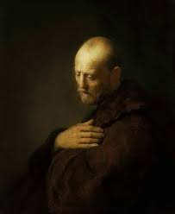
Puritan Prayer:
In Prayer
O Lord, in prayer I launch far out into the eternal world, and on that broad ocean my soul triumphs over all evils on the shores of mortality. Time, with its gay amusements and cruel disappointments never appears so inconsiderate as then.
In prayer I see myself as nothing; I find my heart going after Thee with intensity, and long with vehement thirst to live to Thee. Blessed be the strong gales of the Spirit that speed me on my way to the New Jerusalem.
In prayer all things here below vanish, and nothing seems important but holiness of heart and the salvation of others.
In prayer all my worldly cares, fears, anxieties disappear, and are of as little significance as a puff of wind.
In prayer my soul inwardly exults with lively thoughts at what Thou art doing for Thy church, and I long that Thou shouldest get Thyself a great name from sinners returning to Zion.
In prayer I am lifted above the frowns and flatteries of life, and taste heavenly joys; entering into the eternal world I can give myself to Thee with all my heart, to be Thine for ever.
In prayer I can place all my concerns in Thy hands, to be entirely at Thy disposal, having no will or interest of my own.
In prayer I can intercede for my friends, ministers, sinners, the church, Thy kingdom to come, with greatest freedom, ardent hopes, as a son to his father, as a lover to the beloved.
Help me to be all prayer and never to cease praying.

Aids to the Divine Life. By Thomas Sherman. Chapter VI
THE CHRISTIAN.
"He is but half a Christian who is an orthodox believer, if he be not practical also : and he is but half a Christian who is practical, if he be not an orthodox believer." ---- George Gilltsph, 1649.
I—The Christian's Way Of Access.
Believers under the Gospel "have boldness, and access with confidence, through faith in Christ," (Eph. iii. 12.) Christ leads them as by the hand into the presence of the Father, where they have freedom to make known all their wants, with confidence of success. Under the law, only the High Priest, - and that once a year, was to enter into the Holy of Holies. But now the saints, who are priests unto God, may come with boldness into the holy place daily, " by a new and living way, which is consecrated for them, through the veil; that is to say, the flesh of Christ," (Heb. x. 20.) "A new way:" the word signifies that which is newly slain; referring to the sacrifice of Christ as that which remains always in full force, as if He were but newly slain. Christ, through the efficacy of His blood, hath opened a way of access, and keeps it open for the saints, as though that blood were but newly shed. Again, it is called "a living way:" a way wherein the saints are quickened by the Spirit, and through which they are made more lively. "Your hearts shall live that seek God," (PsaL lxix. 32.) Let those, therefore, who have an interest in this privilege come, as with reverence so with boldness, to the throne of grace, that they may obtain mercy and find grace to help in time of need. As by the assistance of the Spirit they will find it a living way; so through the blood of Christ they will find it a prevailing way.
II.—The Christian A Child or Light.
When men would dignify persons it is customary to attribute such titles to them as are derived from light: as, "Most Splendid," " Most Serene," " Most Illustrious ;" titles frequently misapplied, for how often are they ascribed to the sons of darkness! We read of Antiochus Epiphanes, or Antiochus the Illustrious ; whereas the Holy Ghost, speaking of the same person, as some conclude, calls him "a vile person," (Dan. xi. 21.) Such titles, therefore, declare what their owners should be, rather than what they are. If light then be so glorious, surely the righteous is more excellent than his neighbour; yea, the most excellent in all the earth, (Prov. xii. 26; Ps. xvi. 3.) They are, not in title only but in truth, said to be "light in the Lord," (Eph. v. 8.) They are called by the Holy Ghost himself, "children of the light and of the day," (1 Thess. v. 5.) Let your dignity, therefore, engage you to your duty. Are you children of light? Walk as children of light.
III.—The Christian's Conversation.
It is one thing to have a good conversation in the world, and another to have a good conversation in Christ. Paul, while a Pharisee, had a good conversation in the account of the world, while he walked, according to the law, blameless; but it was not a good conversation in Christ, for he was then a persecutor of Him.
To have a good conversation in Christ requires:—(1.) Union with and implantation into Christ. The tree must be good before the fruit can be good. There may be the doing of that which is materially good upon the stock and root of old Adam; but we cannot do that which is spiritually good till we are cut off from that stock, and grafted into Christ.
(2.) A good conversation in Christ is a conversation flowing from the regenerating work of Christ in the heart; —a new spiritual man formed in our spirits. It must be a walking from a new principle wrought in the soul, called a " serving in the newness of the Spirit," (Eom. vii. 6.) There must be a new creation before there can be a good conversation. We must be "created in Christ Jesus unto good works," before our works can be wrought in God, (Eph. ii 10.)
(3.) A good conversation in Christ arises from a good conscience:" Having a good conscience; that, whereas they speak evil of you, as of evil-doers, they may be ashamed that falsely accuse your good conversation in Christ," (1 Pet. iii. 16.) A good conscience is a conscience purged by the blood of Christ from the guilt of sin, and cleansed by the Spirit of Christ from the power of sin.
(4) To have a good conversation in Christ is, by faith, to be in and drawing virtue from Christ through the whole course of our lives: to be " strong in the grace that is in Christ Jesus," (2 Tim. ii 1.) Not in our own inherent strength, or in the strength of habitual grace received; but to be " strong in the Lord, and in the power of His might," (Eph. vi. 10;) deriving from Christ, as our vital Head and quickening principle, all life, motion, and renewing influences of spirit and grace, for the carrying on of this conversation.
(5.) A good conversation in Christ is to have our works wrought according to the rule of Christ—freely, cheerfully, and vigorously; from a sense of God's love to us, and from the outflowing of our love to Him, (1 Chron. xxviii. 9; Ps. xl. 8; cxix. 35—110; Rom. xii. 11; 2 Cor. v. 14)
(6.) A good conversation in Christ is to do what we do in Christ's name. When in the best frame we perform holy duties in the best manner, without relying on them in the least for acceptance with God, but only on Christ's mediation. "Whatsoever ye do in word or deed, do all in the name of the Lord Jesus, giving thanks to God and the Father by Him," (CoL Hi. 17.)
(7.) A good conversation in Christ, is to direct all we do to a spiritual end. When our natural, civil, moral, relative, and religious actions are so directed, " that God in all things may be glorified through Jesus Christ," (1 Pet iv. 11.) Would you, therefore, order your conversation aright, so as to see the salvation of God? Look to it that your works he wrought in God; that is, in God's strength and to God's glory. For, as without acting from Christ as the source of spiritual life; so, without acting to Christ as the object of loving service, all you do will avail you nothing, (John xv. 5.)

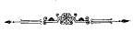

If we Have Not Love, we Have Nothing
It is foretold by our Lord Jesus Christ, that in the last days the “love of many shall wax cold,” (Matt 24:12). And truly this is the symptom of a decaying and a fading Christian and church. Love is the vital spirits of a Christian, which are the principles of all motion and lively operation. When there is a deficiency in these, the soul is in decay; it is so comprehensive an evil, as alone is sufficient to make an evil time. And besides it is the argument and evidence, as well as the root and fountain of abounding iniquity, because this is the epidemical disease of the present time, love cooled, and passion heated, whence proceed all the feverish distempers, contentions, wars and divisions, which have brought the church of God near to expiring. therefore being mindful of that of the apostle Heb 10:24, I would think it pertinent to consider one another, and provoke again unto love and good works. It was the great charge that Christ had against Ephesus, “Thou hast left thy first love.” Remember the excellence and necessity of this grace, so that we may remember from whence we have fallen and repent, that we may do the first works, lest he come quickly and remove our candlestick. (Rev 2:4-5)
—Hugh Binning “Treatise on Christian love”
"Let no man think to kill sin with few, easy, or gentle strokes. He who hath once smitten a serpent, if he follow not on his blow until it be slain, may repent that ever he began the quarrel. And so he who undertakes to deal with sin, and pursues it not constantly to the death." -John Owen

Hymn History

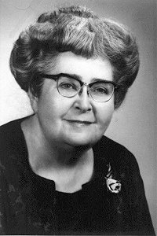
In Times Like These

by

Ruth Caye Jones
1902 - 1972

Late in 1943, Ruth Caye Jones, mother of five and wife of a busy pastor, was reading 2 Timothy 3:1, which says, “In the last days perilous times shall come”(KJV) As she read the Pittsburgh papers, saw the World War II casualty lists, and watched the slow progress of allied troops moving up the boot of Italy, it seemed that perilous times had already come. Rationing was hitting hard; discouragement was everywhere. How long could people continue in times like these?
Ruth took out a small notepad from her apron pocket and started writing some words. A melody came to her as she wrote. She had no formal music training, and she wasn’t trying to do something to make herself famous, but it was the right song for the right time. Soon people around the world were singing it.
Years later, when she watched a Billy Graham telecast and heard George Beverly Shea sing it, tears came to her eyes and she said, “I can’t believe I had any part in writing this son. I just geel that God gave it to me, and I gave it to the world.
In times like these you need a Savior
In times like these you need an anchor
Be very sure, be very sure
Your anchor holds and grips the Solid Rock
Refrain
This Rock is Jesus, Yes He's the One
This Rock is Jesus, the only One
Be very sure, be very sure
Your anchor holds and grips the Solid Rock
In times like these you need the Bible
In times like these O be not idle
Be very sure, be very sure
Your anchor holds and grips the Solid Rock
Refrain;
In times like these I have a Savior
In times like these I have an anchor
I'm very sure, I'm very sure
My anchor holds and grips the Solid Rock
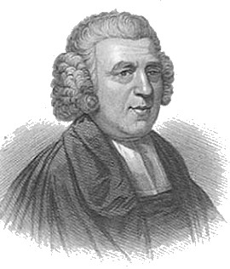
My dear wife has been quite ill
(Letters of John Newton)
"And even the very hairs of your head are all numbered!" Matthew 10:30
Dear friend,
My dear wife has been quite ill. Sickness is a bitter pill to swallow. Yet the Lord is good; He knows what we need, and when we need it. We must and shall have it--whether it is sweet, bitter, or sour--for He will withhold no good thing from those who fear and love Him.
He upholds and enlightens the planets and stars. He weighs the mountains in scales, and the hills in a balance. At the same time, He is providing for the lions and ravens, and supporting all the ants and worms that creep upon the earth!
And with equal accuracy--He adjusts all that concerns us! Worms as we are--He is attentive to everything that relates to our peace and welfare, as though we, each of us singly--were the sole objects of His providential care! Yes, His eye and His heart are attentively fixed upon you and worthless me! Well may we say, "Who is a God like unto You!"
Fox’s Book of Martyrs

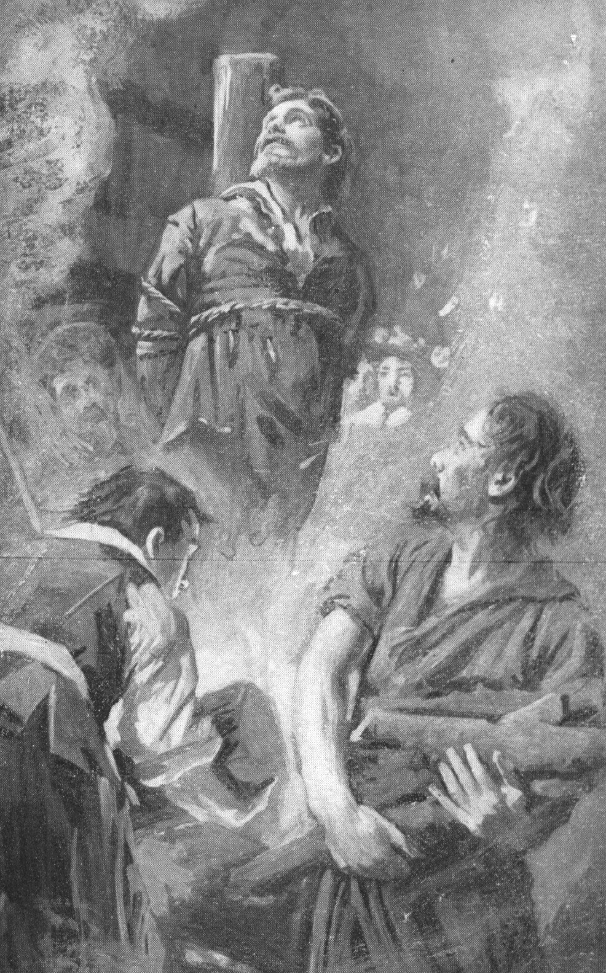
Chapter xvi – Part XXIV (Continued)


Hugh Laverick and John Aprice

Here we perceive that neither the impotence of age nor the affliction of blindness, could turn aside the murdering fangs of these Babylonish mon-sters. The first of these unfortunates was of the parish of Barking, aged sixty-eight, a painter and a cripple. The other was blind, dark indeed in his visual faculties, but intellectually illuminated with the radiance of the everlasting Gospel of truth. Inoffensive objects like these were informed against by some of the sons of bigotry, and dragged before the prelatical shark of London, where they underwent examination, and replied to the articles propounded to them, as other Christian martyrs had done before. On the ninth day of May, in the consistory of St. Paul's, they were entreated to recant, and upon refusal, were sent to Fulham, where Bonner, by way of a dessert after dinner, condemned them to the agonies of the fire. Being consigned to the secular officers, May 15, 1556, they were taken in a cart from Newgate to Stratford-le-Bow, where they were fastened to the stake. When Hugh Laverick was secured by the chain, having no further occasion for his crutch, he threw it away saying to his fellow-martyr, while consoling him, "Be of good cheer my brother; for my lord of London is our good physician; he will heal us both shortly-thee of thy blindness, and me of my lameness." They sank down in the fire, to rise to immortality!
The day after the above martyrdoms, Catharine Hut, of Bocking, widow; Joan Horns, spinster, of Billerica; Elizabeth Thackwel, spinster, of Great Burstead, suffered death in Smithfield.
Thomas Dowry. We have again to record an act of unpitying cruelty, exercised on this lad, whom Bishop Hooper, had confirmed in the Lord and the knowledge of his Word.
How long this poor sufferer remained in prison is uncertain.
By the testimony of one John Paylor, register of Gloucester, we learn that when Dowry was brought before Dr. Williams, then chancellor of Gloucester, the usual articles were presented him for subscription. From these he dissented; and, upon the doctor's demanding of whom and where he had learned his heresies, the youth replied, "Indeed, Mr. Chancellor, I learned from you in that very pulpit. On such a day (naming the day) you said, in preaching upon the Sacrament, that it was to be exercised spiritually by faith, and not carnally and really, as taught by the papists." Dr. Williams then bid him recant, as he had done; but Dowry had not so learned his duty. "Though you," said he, "can so easily mock God, the world, and your own conscience, yet will I not do so." – To be continued.



THE ATTRIBUTES OF GOD
by Arthur Pink
9. THE POWER OF GOD

We cannot have a right conception of God unless we think of Him as all-powerful, as well as all-wise. He who cannot do what he will and perform all his pleasure cannot be God. As God hath a will to resolve what He deems good, so has He power to execute His will.
The power of God is that ability and strength whereby He can bring to pass whatsoever He pleases, whatsoever His infinite wisdom may direct, and whatsoever the infinite purity of His will may resolve. . . . As holiness is the beauty of all God’s attributes, so power is that which gives life and action to all the perfections of the Divine nature. How vain would be the eternal counsels, if power did not step in to execute them. Without power His mercy would be but feeble pity, His promises an empty sound, His threatenings a mere scarecrow. God’s power is like Himself: infinite, eternal, incomprehensible; it can neither be checked, restrained, nor frustrated by the creature. (S. Charnock).
"God hath spoken once; twice have I heard this, that power belongeth unto God" (Ps. 62:11). "God hath spoken once": nothing more is necessary! Heaven and earth shall pass away, but His word abideth forever. God hath spoken once: how befitting His Divine majesty! We poor mortals may speak often and yet fail to be heard. He speaks but once and the thunder of His power is heard on a thousand hills. "The Lord also thundered in the heavens, and the Highest gave His voice; hailstones and coals of fire. Yea, He sent out His arrows, and scattered them; and He shot out lightnings, and discomfited them. Then the channels of waters were seen and the foundations of the world were discovered at Thy rebuke, O Lord, at the blast of the breath of Thy nostrils" (Ps. 18:13-15).
"God hath spoken once": behold His unchanging authority. "For who in the heaven can be compared unto the Lord? who among the sons of the mighty can be likened unto the Lord?" (Ps. 89:6). "And all the inhabitants of the earth are reputed as nothing: and He doeth according to His will in the army of heaven, and among the inhabitants of the earth: and none can stay His hand, or say unto Him, What dost Thou?" (Dan. 4:35). This was openly displayed when God became incarnate and tabernacled among men. To the leper He said, "I Will, be thou clean, and immediately his leprosy was cleansed" (Matt. 8:3). To one who had lain in the grave four days He cried, "Lazarus, come forth," and the dead came forth. The stormy wind and the angry wave were hushed at a single word from Him. A legion of demons could not resist His authoritative command.
"Power belongeth unto God," and to Him alone. Not a creature in the entire universe has an atom of power save what God delegates. But God’s power is not acquired, nor does it depend upon any recognition by any other authority. It belongs to Him inherently.
God’s power is like Himself, self-existent, self-sustained. The mightiest of men cannot add so much as a shadow of increased power to the Omnipotent One. He sits on no buttressed throne and leans on no assisting arm. His court is not maintained by His courtiers, nor does it borrow its splendor from His creatures. He is Himself the great central source and Originator of all power (C. H. Spurgeon).
Not only does all creation bear witness to the great power of God, but also to His entire independency of all created things. Listen to His own challenge: "Where wast thou when I laid the foundations of the earth? declare, if thou hast understanding. Who hath laid the measures thereof, if thou knowest? or who hath stretched the line upon it? Whereupon are the foundations thereof fastened or who laid the cornerstone thereof?" (Job 38:4-6). How completely is the pride of man laid in the dust!
Power is also used as a name of God, the Son of man sitting at the right hand of power (Mark 14:62), that is, at the right hand of God. God and power are so inseparable that they are reciprocated. As His essence is immense, not to be confined in place; as it is eternal, not to be measured in time; so it is almighty, not to be limited in regard of action (S. Charnock).
"Lo, these are parts of His ways:" but how little a portion is heard of Him? but the thunder of His power who can understand? (Job 26:14). Who is able to count all the monuments of His power? Even that which is displayed of His might in the visible creation is utterly beyond our powers of comprehension, still less are we able to conceive of omnipotence itself. There is infinitely more power lodged in the nature of God than is expressed in all His works.
"Parts of His ways" we behold in creation, providence, redemption, but only a "little part" of His might is seen in them. Remarkably is this brought out in Habakkuk 3:4: "and there was the hiding of His power." It is scarcely possible to imagine anything more grandiloquent than the imagery of this whole chapter, yet nothing in it surpasses the nobility of this statement. The prophet (in vision) beheld the mighty God scattering the hills and overturning the mountains, which one would think afforded an amazing demonstration of His power Nay, says our verse, that is rather the "hiding" than the displaying of His power. What is meant? This: so inconceivable, so immense, so uncontrollable is the power of Deity, that the fearful convulsions which He works in nature conceal more than they reveal of His infinite might!
It is very beautiful to link together the following passages: "He walketh upon the waves of the sea" (Job 9:8), which expresses God’s uncontrollable power. "He walketh in the circuit of Heaven" (Job 22:14), which tells of the immensity of His presence. "He walketh upon the wings of the wind" (Ps. 104:3), which signifies the amazing swiftness of His operations. This last expression is very remarkable. It is not that "He flieth," or "runneth," but that He "walketh" and that, on the very "wings of the wind"—on the most impetuous of the elements, tossed into utmost rage, and sweeping along with almost inconceivable rapidity, yet they are under His feet, beneath His perfect control!
Let us now consider God’s power in creation. "The heavens are Thine, the earth also is Thine, as for the world and the fulness thereof, Thou hast founded them. The north and the south Thou hast created them" (Ps. 89:11, 12). Before man can work be must have both tools and materials, but God began with nothing, and by His word alone out of nothing made all things. The intellect cannot grasp it. God "spake and it was done, He commanded and it stood fast" (Ps. 33:9). Primeval matter heard His voice. "God said, Let there be. . .and it was so" (Gen. 1). Well may we exclaim, "Thou hast a mighty arm: strong is Thy hand, high is Thy right hand" (Ps. 89:13).
Who, that looks upward to the midnight sky; and, with an eye of reason, beholds its rolling wonders; who can forbear inquiring, Of what were their mighty orbs formed? Amazing to relate, they were produced without materials. They sprung from emptiness itself. The stately fabric of universal nature emerged out of nothing. What instruments were used by the Supreme Architect to fashion the parts with such exquisite niceness, and give so beautiful a polish to the whole? How was it all connected into one finely-proportioned and nobly finished structure? A bare fiat accomplished all. Let them be, said God. He added no more; and at once the marvelous edifice arose, adorned with every beauty, displaying innumerable perfections, and declaring amidst enraptured seraphs its great Creator’s praise. "By the word of the Lord were the heavens made, and all the host of them by the breath of His mouth," Psa. 150:1 (James Hervey, 1789).
Consider God’s power in preservation. No creature has power to preserve itself. "Can the rush grow up without mire? can the flag grow up without water?" (Job 8:11). Both man and beast would perish if there were not herbs for food, and herbs would wither and die if the earth were not refreshed with fruitful showers. Therefore is God called the Preserver of "man and beast" (Ps. 36:6). "He upholdeth all things by the word of His power" (Heb 1:3). What a marvel of Divine power is the prenatal life of every human being! That an infant can live at all, and for so many months, in such cramped and filthy quarters, and that without breathing, is unaccountable without the power of God. Truly He "holdeth our soul in life" (Ps. 66:9).
The preservation of the earth from the violence of the sea is another plain instance of God’s might. How is that raging element kept pent within those limits wherein He first lodged it, continuing its channel, without overflowing the earth and dashing in pieces the lower part of the creation? The natural situation of the water is to be above the earth, because it is lighter, and to be immediately under the air, because it is heavier. Who restrains the natural quality of it? certainly man does not, and cannot. It is the flat of its Creator which alone bridles it: And said, "Hitherto shalt thou come, but no further: and here shall thy proud waves be stayed" (Job 38:11). What a standing monument of the power of God is the preservation of the world!
Consider God’s power in government. Take His restraining the malice of Satan. "The devil, as a roaring lion, walketh about, seeking whom he may devour" (1 Pet. 5:8). He is filled with hatred against God, and with fiendish enmity against men, particularly the saints. He that envied Adam in paradise, envies us the pleasure of enjoying any of God’s blessings. Could he have his will, he would treat all the same way he treated Job: he would send fire from heaven on the fruits of the earth, destroying the cattle, cause a wind to overthrow our houses, and cover our bodies with boils. But, little as men may realize it, God bridles him to a large extent, prevents him from carrying out his evil designs, and confines him within His ordinations.
So too God restrains the natural corruption of men. He suffers sufficient outbreakings of sin to show what fearful havoc has been wrought by man’s apostasy from his Maker, but who can conceive the frightful lengths to which men would go were God to remove His curbing hand? "Their mouth is full of cursing and bitterness their feet are swift to shed blood" (Rom. 3). This is the nature of every descendant of Adam. Then what unbridled licentiousness and headstrong folly would triumph in the world, if the power of God did not interpose to lock down the floodgates of it! See Psalm 93:3,4.
Consider God’s power in judgment. When He smites, none can resist Him: see Ezekiel 22:14.How terribly this was exemplified at the Flood! God opened the windows of heaven and broke up the great fountains of the deep, and (excepting those in the ark) the entire human race, helpless before the storm of His wrath, was swept away. A shower of fire and brimstone from heaven, and the cities of the plain were exterminated. Pharaoh and all his hosts were impotent when God blew upon them at the Red Sea. What a terrific word is that in Romans 9:22: "What if God, willing to show wrath, and to make His power known, endured with much long-suffering the vessels of wrath fitted to destruction." God is going to display His mighty power upon the reprobate not merely by incarcerating them in Gehenna, but by supernaturally preserving their bodies as well as souls amid the eternal burnings of the Lake of Fire.
Well may all tremble before such a God! To treat with impunity One who can crush us more easily than we can a moth, is a suicidal policy. To openly defy Him who is clothed with omnipotence, who can rend us in pieces or cast into Hell any moment He pleases, is the very height of insanity. To put it on its lowest ground, it is but the part of wisdom to heed His command, "Kiss the Son. lest He be angry, and ye perish from the way, when His wrath is kindled but a little" (Ps. 2:12).
Well may the enlightened soul adore such a God! The wondrous and infinite perfections of such a Being call for fervent worship. If men of might and renown claim the admiration of the world, how much more should the power of the Almighty fill us with wonderment and homage. "Who is like unto Thee, O Lord, among the who is like Thee, glorious in holiness, fearful in praises, doing wonders?" (Ex. 15:11).
Well may the saint trust such a God! He is worthy of implicit confidence. Nothing is too hard for Him. If God were stinted in might and had a limit to His strength we might well despair. But seeing that He is clothed with omnipotence, no prayer is too hard for Him to answer, no need too great for Him to supply, no passion too strong for Him to subdue; no temptation too powerful for Him to deliver from, no misery too deep for Him to relieve. "The Lord is the strength of my life; of whom shall I be afraid?" (Ps. 27:1). "Now unto Him that is able to do exceeding abundantly above all that we ask or think, according to the power that worketh in us, unto Him be glory in the church by Christ Jesus throughout all ages, world without end. Amen" (Eph. 3:20,21).
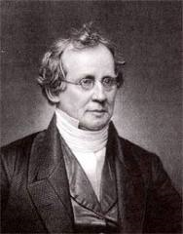
A Christian’s Death.
Thou shalt call His name Jesus: for He shall save His people from their sins. --Matt. 1:21
As Professor Hodge of Princeton was laying on his dying bed, and just before he breathed his last, after saying, “My work is done; the pins of the tabernacle are taken out,” he began to repeat the lines,--
A guilty, weak, and helpless worm,
On Thy kind arm I fall,
When his power of utterance seemed to fail. His sorrowstricken wife, who was by his bedside, finished the stanze thus,--
Be Thou my strength and riteousness,
My Saviour, and my all.
Say Jesus, said her dying husband, and then breathed his last.

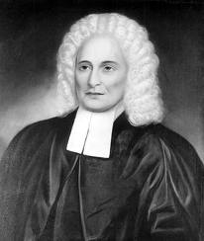
THe Preached His Own Funeral Service
he Rev. Samuel Davies preached his own "funeral service” - and it had an evangelistic theme. Presidents at Princeton were accustomed to preach New Year’s Day sermons, and in 1761 Davies selected as his text Jeremiah 27:16: "Thus saith the Lord, this year thou shalt die." (Past President Aaron Burr, Sr., had selected the same text for a New Year’s Day service in 1757, and when he died later that year, the text was considered to be bad luck. Davies scoffed at the superstitious, but he fell ill shortly after the January 1 service and eventually died on February 4.) Davies urges his hearers to respond to Christ, as it was the only way to "secure a happy new year ... that will lead the way to a happy eternity.”
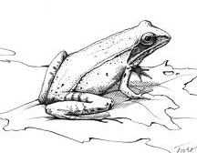
God’s Wonderful Creation

The Champion of Frozen Frogs

“Out of whose womb came the ice? and the hoary frost of heaven, who hath gendered it?” --- Job 38:29

The Wood Frog is the absolute champion at surviving below-freezing temperatures.
Most frogs that survive northern winters cannot withstand more than a few degrees below freezing before they begin to suffer cell damage. Researchers placed Wood Frogs into an industrial freezer where they became stiff and hard on the outside, and partially liquid on the inside. The frogs’ metabolism stopped, and they became brain-dead. When they were thawed out, however, they returned to life as if nothing had ever happened. Wood Frogs avoid cell damage caused by the formation of ice crystals by generating glucose – a highly effective antifreeze. Other species of frogs produce glycerol, a less-effective type of antifreeze. However, the levels of glucose generated by the Wood Frog would cause cell damage in most other frogs, but these frogs limit the damage by shutting off their metabolism. What’s more, should the Wood Frog suffer any cell damage by ice crystal formation, its blood contains a special fibrinogen that seals any leaks in its cell walls.
It is unlikely that all these different systems would evolve perfectly all at the same time. The Wood Frog is an example of a creature where everything had to work perfectly the first time – a testimony to our Creator.
Prayer: I thank You, Lord, that You care for all Your creatures. Amen.
Notes: Discover, 2/05, pp.20-21, Elizabeth Svoboda, “Waking From a Dead Sleep.”
I have resolved to pray more and pray always, to pray in all places where quietness inviteth, in the house, on the highway, and on the street; and to know no street or passage in this city that may not witness that I have not forgotten God.. --- Sir Thomas Browne

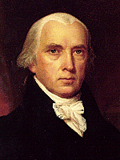
One Nation Under God
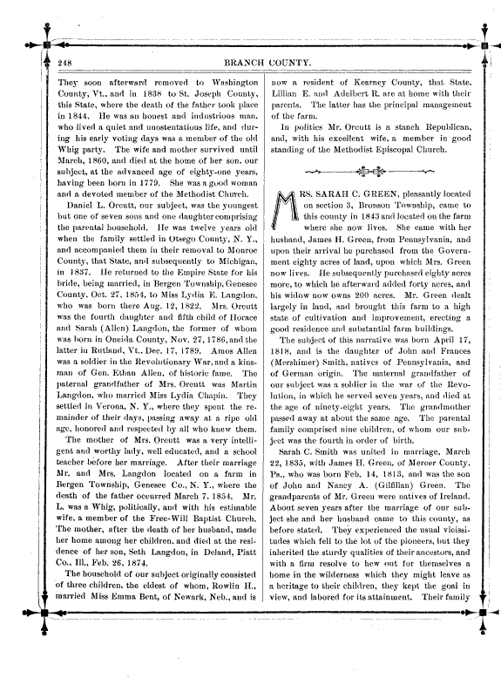
History - Like lightening in the night - Reveals the darkness...

James

Madison

James Madison, co-author of the “Federalist Papers,” was an Episcopalian and trained for the ministry with the Rev. Dr. John Witherspoon. He was a member of the Virginia legislature from 1776-80 and 1784-86, of the Continental Congress in 1780-83, and the Constitutional Convention in 1787. It was in that Convention that he earned the title "Father of the Constitution."
He was a sponsor of the Bill of Rights while a member of the House of Representatives from 1789 to 1797, and authored the Virginia Resolutions of 1798 in opposition to the Alien and Sedition Act. He was Secretary of State from 1801 to 1809, 4th President of the United States from 1809 to 1817, and rector of the University of Virginia for ten years beginning in 1826.
He wrote on November 9, 1772 in a letter to William Bradford:
“A watchful eye must be kept on ourselves lest while we are building ideal monuments of Renown and Bliss here we neglect to have our names enrolled in the Annals of Heaven.”
In September of 1773, in a letter to William Bradford, he wrote:
“I have sometimes thought there could be no stronger testimony in favor of Religion or against temporal Enjoyments even the most rational and manly than for men who occupy the most honorable and gainful departments and are rising in reputation and wealth, publicly to declare their unsatisfactoriness by becoming fervent Advocates in the cause of Christ, & I wish you may give in your Evidence in this way. Such instances have seldom occurred, therefore they would be more striking and would be instead of a "Cloud of Witnesses."
In 1785, in Memorial and Remonstrance Against Religious Assessments, Madison wrote:
"It is the duty of every man to render to the Creator such homage. Before any man can be considered as a member of Civil Society, he must be considered as a subject of the Governor of the Universe.
"We have staked the whole future of American civilization, not upon the power of government, far from it. We have staked the future of all our political institutions upon the capacity of mankind for self government; upon the capacity of each and all of us to govern ourselves, to control ourselves to sustain ourselves according to the Ten Commandments of God."
Although he did speak of a "wall of separation," it is evident that the purpose of said "wall" was to prevent Congress from passing a national law to establish a national religion.
In an 1803 letter objecting to the use of government land for churches, he wrote:
“The purpose of separation of church and state is to keep forever from these shores the ceaseless strife that has soaked the soil of Europe in blood for centuries.”
Madison was in the habit of making notes in his personal Bible, wrote this in Acts, Chapter 19:
“Believers who are in a state of grace, have need of the Word of God for their edification and building up therefore implies a possibility of falling. v. 32.
“Grace, it is the free gift of God. Luke. 12. 32-v.32.
“Giver more blessed than the receiver. v. 35.
“To neglect the means for our own preservation is to tempt God: and to trust to them is to neglect Him. v. 3 & Ch. 27. v. 31.
“Humility, the better any man is, the lower thoughts he has of himself. v. 19.
“Ministers to take heed to themselves & their flock. v. 28.
“The Apostles did greater miracles than Christ, in the matter, not manner, of them. v. 11.”
What a Tract Did.

Rev. Watts, a Methodist preacher was once asked to preach at Newbold, near Rugby. It was his practice, in those days, to distribute tracts from house to house. At one house a very sullen man was having his tea. When Watts invited him to the preaching, he said, “I shan’t come.” “Well, now, said Mr. Watts, “come, and we will try to do you some good.” “I shan’t come,” he firmly replied. “Then perhaps you will read this tract.” Mr. Watts placed the tract gently beside the old man and without waiting for reply went to the next door. Some time after, while Mr. Watts was leading a love-feast at Rugby, this man stood up in the gallery, and praised God for what He had done for his soul, stating that it was through reading the tract left him at the time spoken of. What encouragement to tract-distributers to persevere in their good work!
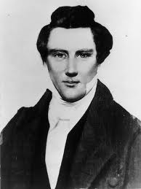
NEW Mormonism

Striving for perfection
and
the true gospel
Joseph Smith
Founder of Mormanism

The Church of Jesus Christ of Latter-day Saints teaches that its members are to strive to be perfect. This perfection, hopefully, results in exaltation, in becoming a god. Very often Mormons will quote the Bible to support their position: "Therefore you are to be perfect, as your heavenly Father is perfect," (Matt. 5:48). Note it says to be perfect, not become perfect. Mormons teach that to be perfect means to become a god, which is a future occurrence, yet the verse says to be perfect in the present tense, not the future.
In addition, the book of Mormon says:
"For we labor diligently to write, to persuade our children, and also our brethren, to believe in Christ, and to be reconciled to God; for we know that it is by grace that we are saved, after all we can do," (2 Nephi 25:23).
Note that it says they are saved by grace after all they can do. This confirms the Mormon teaching of working very hard to be good, to do good works, and to attain to the highest level of exaltation.
The inclination to be perfect in Mormonism is repeatedly taught to its members. This perfection is not merely trying, it means to triumph over sin:
Spencer W. Kimball 1 said: "Being perfect means to triumph over sin. This is a mandate from the Lord. He is just and wise and kind. He would never require anything from his children which was not for their benefit and which was not attainable. Perfection therefore is an achievable goal."2
As you can see, the Mormon is taught that he must triumph over sin, that he is saved by grace after all he can do, and that he must be perfect. In fact, many Mormons have told me that the gospel is the Law and Ordinances of the Mormon Church, further verifying that forgiveness of sins in the LDS church is dependent upon the persistent and necessary effort of the Mormon to keep the Laws of God.

My sympathy to the Mormon
I sincerely sympathize with the Mormon who is seeking to please God, honor Him, and bring glory to Him by trying to obey His commandments. However, when all is said and done and in the quite of his own heart, when he faces the reality of God and his lack of holiness and perfection, can anyone say he has done all he can do, has triumphed over sin, and is perfect? Of course not.
Mormonism teaches that salvation/exaltation is based upon keeping the Law. But, isn't this a great burden upon the Mormon? Isn't keeping the Law of God and seeking to be perfect (in order to become a god) a great strain? How do Mormons deal with their persistent sins and failures that reveal that they are not being perfect, that they are not triumphing over sin? If they are not triumphing, and not doing all they can do, then will they not be cast into outer darkness?
Please understand that I am not in any way mocking the situation of the Mormons or their sincerity to do what they feel is right. But, we must ask whether or not anyone can achieve perfection through his own efforts of keeping the Law or any part of it.
- "For whoever keeps the whole law and yet stumbles in one point, he has become guilty of all," (James 2:10).
- "For as many as are of the works of the Law are under a curse; for it is written, 'Cursed is everyone who does not abide by all things written in the book of the law, to perform them, (Gal. 3:10).
The Bible teaches us that if you want to be made right before God based on your efforts, then you better not make any mistakes. If you do, then you are guilty of all of the Law! This is not good news. If anything, this is what condemns us since the Bible says "through the Law comes the knowledge of sin," (Rom. 3:20). The Law, the commandments, are those things that when we break them, and we all do, condemns us by revealing our sinfulness. And since anyone who keeps the Law must keep all of the Law, and since he cannot, he is only fit to be cast out into outer darkness for not being perfect!
Continued –“What is the Gospel.” Courtesy of carm.org
Father, I wait thy daily will, / Thou shalt divide my portion still, / Grant me on earth what seems thee best, /Till death and heaven reveal the rest. --- Isaac Watts
Romans 12:1 I beseech you therefore, brethren, by the mercies of God, that ye present your bodies a living sacrifice, holy, acceptable unto God, which is your reasonable service.

