Today, the American political landscape is focusing on the primaries and caucuses that are to be held. One of the Republican hopefuls is former Massachusetts Governor Mitt Romney. Mr. Romney has declared that he is a Mormon and that his faith is significant in his life. In other words, he is a practicing Mormon. There have been several Christian people who have come out in support of this man. The most significant is the Chancellor of Bob Jones University Dr. Bob Jones III. Dr. Jones said of his support of Gov. Romney, “As a Christian I am completely opposed to the doctrines of Mormonism. But I’m not voting for a preacher. I’m voting for a president. It boils down to who can best represent conservative American beliefs, not religious beliefs.” (www.foxnews.com 10/17/07) The Church of Jesus Christ of Latter Day Saints (Mormons) are known for being pro-life, anti-homosexual and pro-family; but we need to look further than just these surface topics. Let’s take a look at exactly what Mormonism says.

- God the Father was once a man.
- God and his wife have physical bodies.
- Jesus was created as a spirit child.
- Jesus received a body through a sexual union between Elohim and Mary.
- Jesus and His death on the cross do not fully atone for sin.
- Only the works of Mormon teaching and Mormon membership can give eternal life.
- Worthy men may one day become gods.
- Mormonism says it is Christian but is extremely deceptive. (Taken from The God Makers by Hunt and Decker and Kingdom of the Cults by Walter Martin)

It is obvious by comparing, or should I say contrasting, Mormon teaching with the Bible that Mormonism is a false, unscriptural, soul-damning lie!! Be warned, beware and be vigilant!

For your own Bible study, read Genesis 1 and see which came first-God or man. Then go on and read the Gospels and read about the conception, birth, death and resurrection of Jesus. Do your own research and see if Mormonism lines up with Scripture.

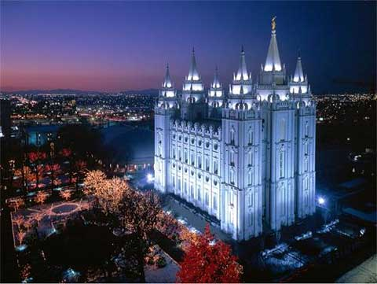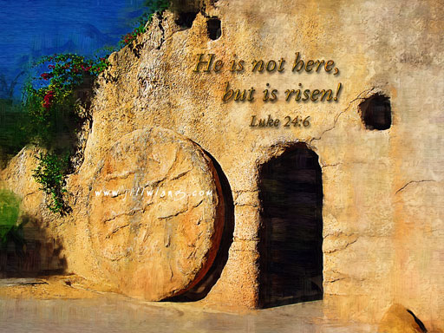

The Mormon Temple in Salt Lake City or The Empty Tomb of Jesus

